Chapter 4: Character Origins

**CHRIS RALLIS**[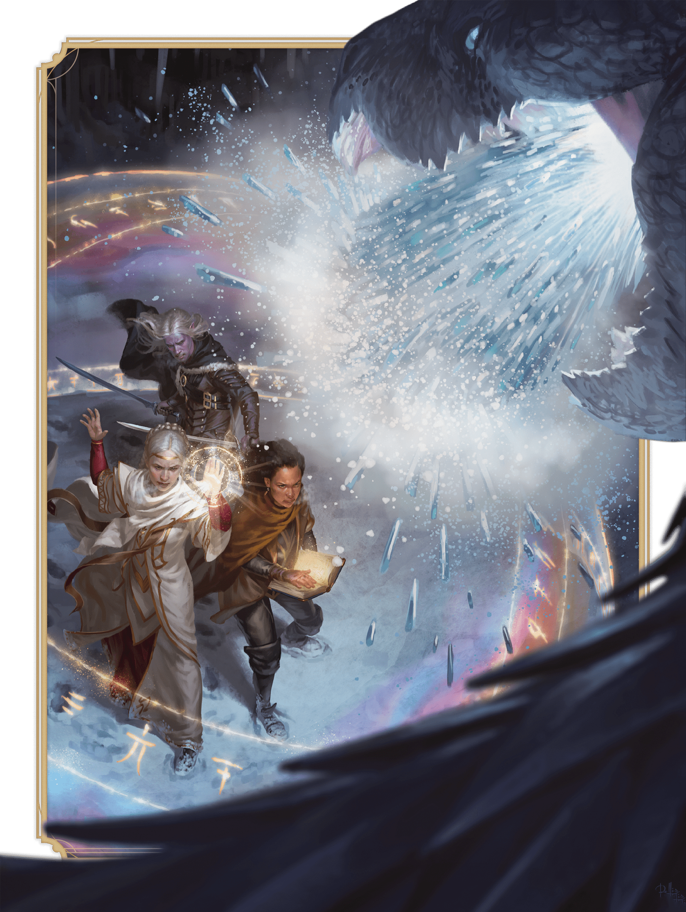](https://media.dndbeyond.com/compendium-images/phb/MKDHZ1nxSXDDLOw2/05-001.laeral-drizzt-vajra.png)Not even a white dragon’s wrath can chill these heroes of the  
Forgotten Realms: Laeral Silverhand, Drizzt Do’Urden, and Vajra Safahr

This chapter describes the two components of an adventurer’s origin: [background](https://www.dndbeyond.com/sources/dnd/phb-2024/character-origins#BackgroundDescriptions) and [species](https://www.dndbeyond.com/sources/dnd/phb-2024/character-origins#SpeciesDescriptions). Together, these elements suggest your character’s early experience and family origin before taking up the adventuring life and learning the capabilities of a class (described in [chapter 3](https://www.dndbeyond.com/sources/dnd/phb-2024/character-classes/)).

Origin Components

Each part of your character’s origin reflects facets of your character, their life, and the circumstances that started them on the path to adventure.

If you choose a background or a species from an older book, see the sidebar “[Backgrounds and Species from Older Books](https://www.dndbeyond.com/sources/dnd/phb-2024/creating-a-character#BackgroundsandSpeciesfromOlderBooks)” in [chapter 2](https://www.dndbeyond.com/sources/dnd/phb-2024/creating-a-character/) for how to use them with the options here.

Character Backgrounds

Your character’s background is a collection of characteristics that represent the place and occupation that were most formative before your character embarked on a life of adventure.

Each background includes a brief narrative of what your character’s past might have been like. Alter the details of this narrative however you like.

**Parts of a Background**

A background includes the following parts.

***Ability Scores.*** A background lists three of your character’s ability scores. Increase one by 2 and another one by 1, or increase all three by 1. None of these increases can raise a score above 20.

***Feat.*** A background gives your character a specified Origin feat (described in [chapter 5](https://www.dndbeyond.com/sources/dnd/phb-2024/feats#OriginFeats)).

***Skill Proficiencies.*** A background gives your character proficiency in two specified skills.

***Tool Proficiency.*** Each background gives a character proficiency with one tool—either a specific tool or one chosen from the Artisan’s Tools category. Tools are detailed in [chapter 6](https://www.dndbeyond.com/sources/dnd/phb-2024/equipment" \l "Tools).

***Equipment.*** Each background offers a choice between a package of equipment and 50 GP.

Character Species

When you choose your character’s species, you determine whether your character is a human or a member of a fantastical species, such as dragonborn or gnome.

The peoples of the D&D multiverse hail from different worlds and include many kinds of sapient life forms. A player character’s species is the set of game traits that an adventurer gains from being one of those life forms.

Some species can trace their origin to a single world, plane of existence, or god, while other species first appeared in multiple realms at once. Whatever a species’ genesis, its members have spread across the multiverse and contribute to many different cultures.

Members of most species live for about 80 years, with exceptions noted in the text about the species in this chapter. Regardless of life span, members of all species reach physical maturity at about the same age. Your character can be any age that isn’t beyond their species’ normal life span.

**Parts of a Species**

A species includes the following parts.

***Creature Type.*** A character’s species determines the character’s creature type, which is described in the rules glossary. Every species in this chapter is Humanoid; playable non-Humanoid species appear in other D&D books.

***Size.*** Your character’s species determines the character’s size. Individuals within a species cover a wide range of heights, and some species include such diversity of size that you can choose whether your character is Small or Medium.

***Speed.*** Your character’s species determines the character’s Speed.

***Special Traits.*** Each species gives a character special traits—unique characteristics based on the species’ physiology or magical nature. When you choose a species, your character gets all the special traits listed for it. Some traits involve making a choice from a handful of options.

Background Descriptions

Sixteen backgrounds are presented in this section in alphabetical order:

[Acolyte](https://www.dndbeyond.com/sources/dnd/phb-2024/character-origins" \l "Acolyte)

[Artisan](https://www.dndbeyond.com/sources/dnd/phb-2024/character-origins#Artisan)

[Charlatan](https://www.dndbeyond.com/sources/dnd/phb-2024/character-origins#Charlatan)

[Criminal](https://www.dndbeyond.com/sources/dnd/phb-2024/character-origins#Criminal)

[Entertainer](https://www.dndbeyond.com/sources/dnd/phb-2024/character-origins#Entertainer)

[Farmer](https://www.dndbeyond.com/sources/dnd/phb-2024/character-origins#Farmer)

[Guard](https://www.dndbeyond.com/sources/dnd/phb-2024/character-origins" \l "Guard)

[Guide](https://www.dndbeyond.com/sources/dnd/phb-2024/character-origins" \l "Guide)

[Hermit](https://www.dndbeyond.com/sources/dnd/phb-2024/character-origins" \l "Hermit)

[Merchant](https://www.dndbeyond.com/sources/dnd/phb-2024/character-origins" \l "Merchant)

[Noble](https://www.dndbeyond.com/sources/dnd/phb-2024/character-origins" \l "Noble)

[Sage](https://www.dndbeyond.com/sources/dnd/phb-2024/character-origins" \l "Sage)

[Sailor](https://www.dndbeyond.com/sources/dnd/phb-2024/character-origins" \l "Sailor)

[Scribe](https://www.dndbeyond.com/sources/dnd/phb-2024/character-origins#Scribe)

[Soldier](https://www.dndbeyond.com/sources/dnd/phb-2024/character-origins#Soldier)

[Wayfarer](https://www.dndbeyond.com/sources/dnd/phb-2024/character-origins#Wayfarer)

Acolyte

**TITUS LUNTER**[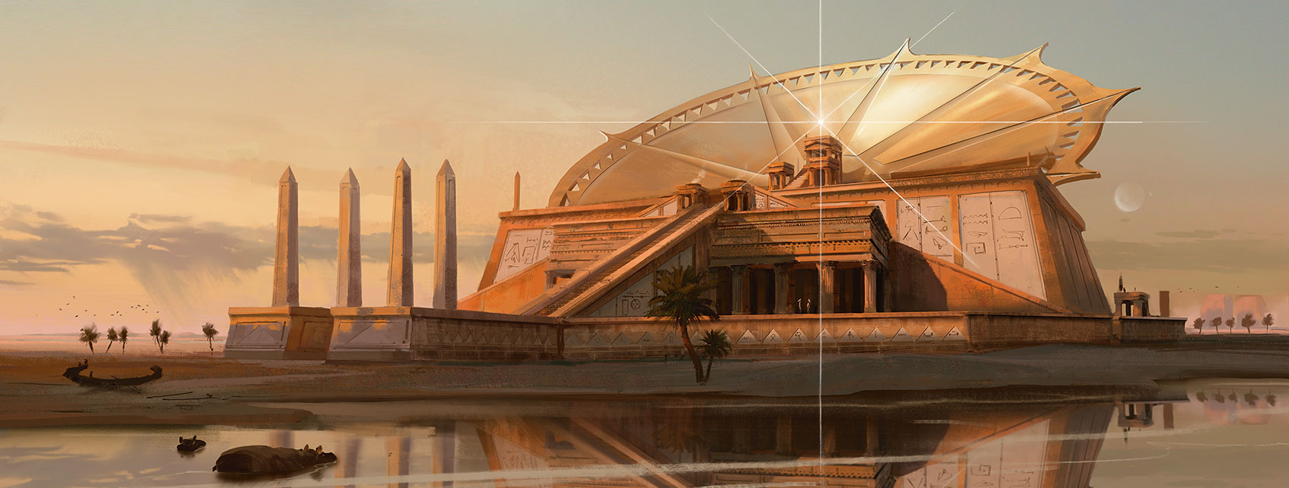](https://media.dndbeyond.com/compendium-images/phb/MKDHZ1nxSXDDLOw2/05-002.acolyte.jpg)

**Ability Scores:** Intelligence, Wisdom, Charisma

**Feat:** Magic Initiate (Cleric) (see [chapter 5](https://www.dndbeyond.com/sources/dnd/phb-2024/feats#MagicInitiate))

**Skill Proficiencies:** **[Insight](https://www.dndbeyond.com/sources/dnd/free-rules/playing-the-game" \l "Skills)** and **[Religion](https://www.dndbeyond.com/sources/dnd/free-rules/playing-the-game" \l "Skills)**

**Tool Proficiency:** Calligrapher’s Supplies

**Equipment:** *Choose A or B:* (A) [**Calligrapher’s Supplies**](https://www.dndbeyond.com/equipment/404-calligraphers-supplies), [**Book**](https://www.dndbeyond.com/equipment/439-book) (prayers), [**Holy Symbol**](https://www.dndbeyond.com/equipment/514-holy-symbol), [**Parchment**](https://www.dndbeyond.com/equipment/395-parchment) (10 sheets), [**Robe**](https://www.dndbeyond.com/equipment/412-robe), 8 GP; or (B) 50 GP

You devoted yourself to service in a temple, either nestled in a town or secluded in a sacred grove. There you performed rites in honor of a god or pantheon. You served under a priest and studied religion. Thanks to your priest’s instruction and your own devotion, you also learned how to channel a modicum of divine power in service to your place of worship and the people who prayed there.

Artisan

**LUCA BANCONE**[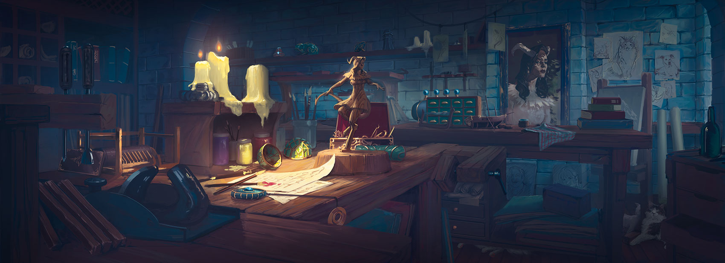](https://media.dndbeyond.com/compendium-images/phb/MKDHZ1nxSXDDLOw2/05-003.artisan.jpg)

**Ability Scores:** Strength, Dexterity, Intelligence

**Feat:** Crafter (see [chapter 5](https://www.dndbeyond.com/sources/dnd/phb-2024/feats" \l "Crafter))

**Skill Proficiencies:** [**Investigation**](https://www.dndbeyond.com/sources/dnd/free-rules/playing-the-game#Skills) and [**Persuasion**](https://www.dndbeyond.com/sources/dnd/free-rules/playing-the-game#Skills)

**Tool Proficiency:** *Choose one kind of Artisan’s Tools* (see [chapter 6](https://www.dndbeyond.com/sources/dnd/phb-2024/equipment#ArtisansTools))

**Equipment:** *Choose A or B:* (A) Artisan’s Tools (same as above), 2 [**Pouches**](https://www.dndbeyond.com/equipment/403-pouch), [**Traveler’s Clothes**](https://www.dndbeyond.com/equipment/541-travelers-clothes), 32 GP; or (B) 50 GP

You began mopping floors and scrubbing counters in an artisan’s workshop for a few coppers per day as soon as you were strong enough to carry a bucket. When you were old enough to apprentice, you learned to create basic crafts of your own, as well as how to sweet-talk the occasional demanding customer. Your trade has also given you a keen eye for detail.

Charlatan

**LUCA BANCONE**[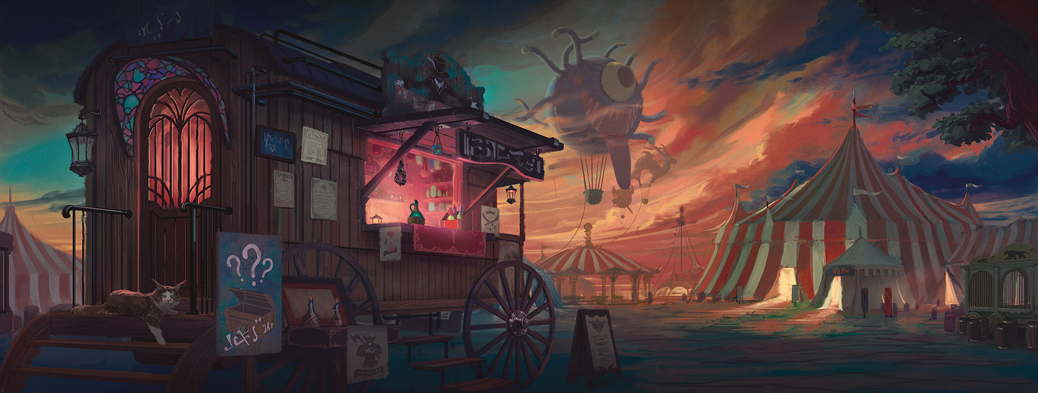](https://media.dndbeyond.com/compendium-images/phb/MKDHZ1nxSXDDLOw2/05-004.charlatan.jpg)

**Ability Scores:** Dexterity, Constitution, Charisma

**Feat:** Skilled (see [chapter 5](https://www.dndbeyond.com/sources/dnd/phb-2024/feats#Skilled))

**Skill Proficiencies:** [**Deception**](https://www.dndbeyond.com/sources/dnd/free-rules/playing-the-game#Skills) and [**Sleight of Hand**](https://www.dndbeyond.com/sources/dnd/free-rules/playing-the-game#Skills)

**Tool Proficiency:** Forgery Kit

**Equipment:** *Choose A or B:* (A) [**Forgery Kit**](https://www.dndbeyond.com/equipment/543-forgery-kit), [**Costume**](https://www.dndbeyond.com/equipment/536-costume), [**Fine Clothes**](https://www.dndbeyond.com/equipment/539-fine-clothes), 15 GP; or (B) 50 GP

Once you were old enough to order an ale, you soon had a favorite stool in every tavern within ten miles of where you were born. As you traveled the circuit from public house to watering hole, you learned to prey on unfortunates who were in the market for a comforting lie or two—perhaps a sham potion or forged ancestry records.

Criminal

**NOOR RAHMAN**[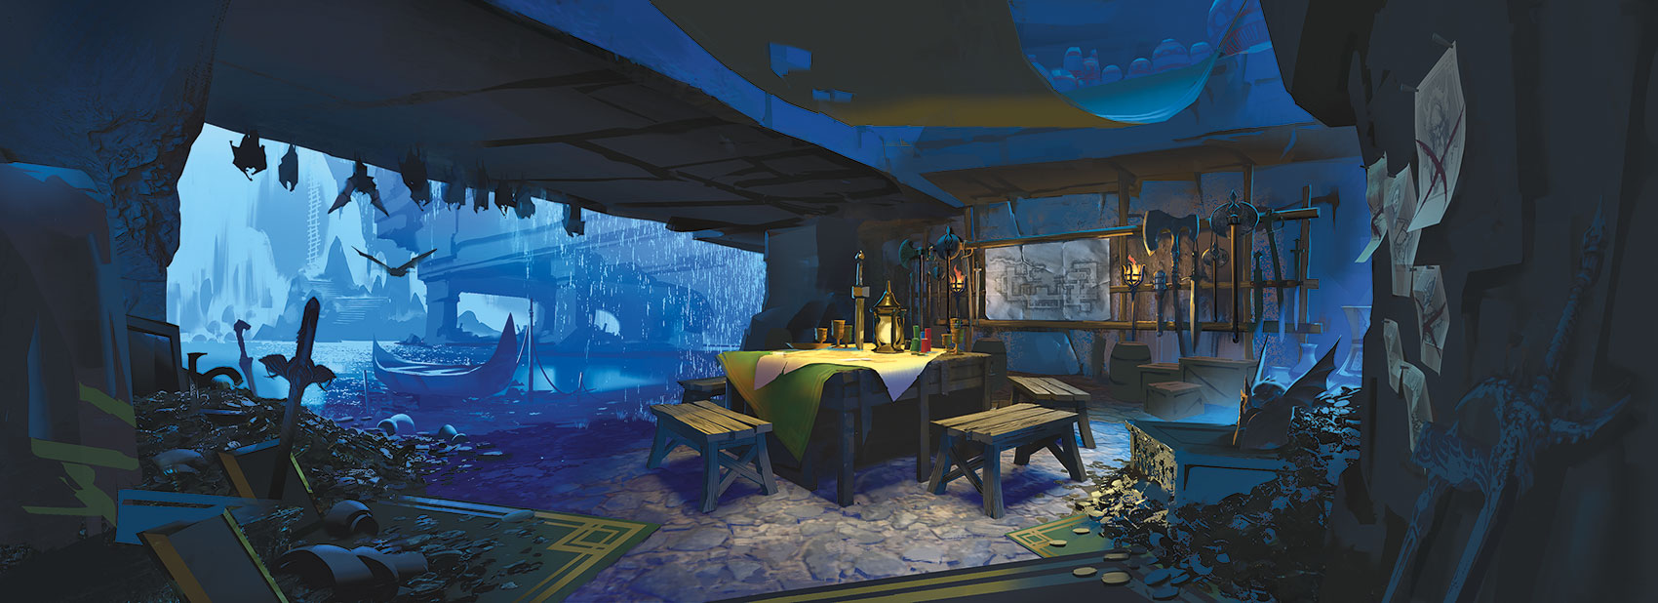](https://media.dndbeyond.com/compendium-images/phb/MKDHZ1nxSXDDLOw2/05-005.criminal.jpg)

**Ability Scores:** Dexterity, Constitution, Intelligence

**Feat:** Alert (see [chapter 5](https://www.dndbeyond.com/sources/dnd/phb-2024/feats#Alert))

**Skill Proficiencies:** **[Sleight of Hand](https://www.dndbeyond.com/sources/dnd/free-rules/playing-the-game" \l "Skills)** and [**Stealth**](https://www.dndbeyond.com/sources/dnd/free-rules/playing-the-game#Skills)

**Tool Proficiency:** Thieves’ Tools

**Equipment:** *Choose A or B:* (A) 2 [**Daggers**](https://www.dndbeyond.com/equipment/3-dagger), [**Thieves’ Tools**](https://www.dndbeyond.com/equipment/495-thieves-tools), [**Crowbar**](https://www.dndbeyond.com/equipment/535-crowbar), 2 [**Pouches**](https://www.dndbeyond.com/equipment/403-pouch), [**Traveler’s Clothes**](https://www.dndbeyond.com/equipment/541-travelers-clothes), 16 GP; or (B) 50 GP

You eked out a living in dark alleyways, cutting purses or burgling shops. Perhaps you were part of a small gang of like-minded wrongdoers who looked out for each other. Or maybe you were a lone wolf, fending for yourself against the local thieves’ guild and more fearsome lawbreakers.

Entertainer

**KENNY VO**[](https://media.dndbeyond.com/compendium-images/phb/MKDHZ1nxSXDDLOw2/05-006.entertainer.jpg)

**Ability Scores:** Strength, Dexterity, Charisma

**Feat:** Musician (see [chapter 5](https://www.dndbeyond.com/sources/dnd/phb-2024/feats" \l "Musician))

**Skill Proficiencies:** [**Acrobatics**](https://www.dndbeyond.com/sources/dnd/free-rules/playing-the-game#Skills) and [**Performance**](https://www.dndbeyond.com/sources/dnd/free-rules/playing-the-game#Skills)

**Tool Proficiency:** *Choose one kind of Musical Instrument* (see [chapter 6](https://www.dndbeyond.com/sources/dnd/phb-2024/equipment#MusicalInstrumentVaries))

**Equipment:** *Choose A or B:* (A) Musical Instrument (same as above), 2 [**Costumes**](https://www.dndbeyond.com/equipment/536-costume), [**Mirror**](https://www.dndbeyond.com/equipment/484-mirror), [**Perfume**](https://www.dndbeyond.com/equipment/396-perfume), [**Traveler’s Clothes**](https://www.dndbeyond.com/equipment/541-travelers-clothes), 11 GP; or (B) 50 GP

You spent much of your youth following roving fairs and carnivals, performing odd jobs for musicians and acrobats in exchange for lessons. You may have learned how to walk a tightrope, how to play a lute in a distinct style, or how to recite poetry with impeccable diction. To this day, you thrive on applause and long for the stage.

Farmer

**KENNY VO**[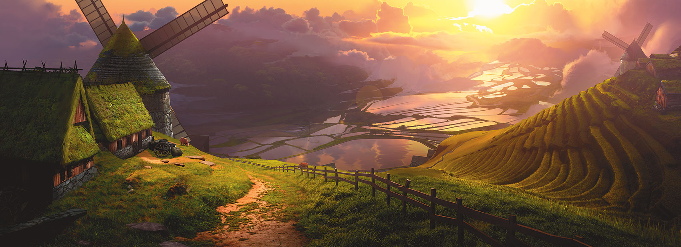](https://media.dndbeyond.com/compendium-images/phb/MKDHZ1nxSXDDLOw2/05-007.farmer.jpg)

**Ability Scores:** Strength, Constitution, Wisdom

**Feat:** Tough (see [chapter 5](https://www.dndbeyond.com/sources/dnd/phb-2024/feats" \l "Tough))

**Skill Proficiencies:** [**Animal Handling**](https://www.dndbeyond.com/sources/dnd/free-rules/playing-the-game#Skills) and [**Nature**](https://www.dndbeyond.com/sources/dnd/free-rules/playing-the-game#Skills)

**Tool Proficiency:** Carpenter’s Tools

**Equipment:** *Choose A or B:* (A) [**Sickle**](https://www.dndbeyond.com/equipment/13-sickle), [**Carpenter’s Tools**](https://www.dndbeyond.com/equipment/409-carpenters-tools), [**Healer’s Kit**](https://www.dndbeyond.com/equipment/515-healers-kit), [**Iron Pot**](https://www.dndbeyond.com/equipment/401-iron-pot), [**Shovel**](https://www.dndbeyond.com/equipment/422-shovel), [**Traveler’s Clothes**](https://www.dndbeyond.com/equipment/541-travelers-clothes), 30 GP; or (B) 50 GP

You grew up close to the land. Years tending animals and cultivating the earth rewarded you with patience and good health. You have a keen appreciation for nature’s bounty alongside a healthy respect for nature’s wrath.

Guard

**NOOR RAHMAN**[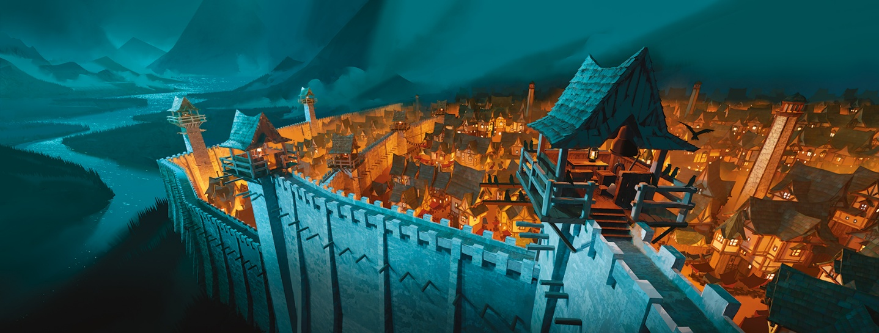](https://media.dndbeyond.com/compendium-images/phb/MKDHZ1nxSXDDLOw2/05-008.guard.jpg)

**Ability Scores:** Strength, Intelligence, Wisdom

**Feat:** Alert (see [chapter 5](https://www.dndbeyond.com/sources/dnd/phb-2024/feats#Alert))

**Skill Proficiencies:** [**Athletics**](https://www.dndbeyond.com/sources/dnd/free-rules/playing-the-game#Skills) and [**Perception**](https://www.dndbeyond.com/sources/dnd/free-rules/playing-the-game#Skills)

**Tool Proficiency:** *Choose one kind of Gaming Set* (see [chapter 6](https://www.dndbeyond.com/sources/dnd/phb-2024/equipment#GamingSetVaries))

**Equipment:** *Choose A or B:* (A) [**Spear**](https://www.dndbeyond.com/equipment/14-spear), [**Light Crossbow**](https://www.dndbeyond.com/equipment/15-crossbow-light), 20 [**Bolts**](https://www.dndbeyond.com/equipment/510-bolts), Gaming Set (same as above), [**Hooded Lantern**](https://www.dndbeyond.com/equipment/493-hooded-lantern), [**Manacles**](https://www.dndbeyond.com/equipment/487-manacles), [**Quiver**](https://www.dndbeyond.com/equipment/407-quiver), [**Traveler’s Clothes**](https://www.dndbeyond.com/equipment/541-travelers-clothes), 12 GP; or (B) 50 GP

Your feet ache when you remember the countless hours you spent at your post in the tower. You were trained to keep one eye looking outside the wall, watching for marauders sweeping from the nearby forest, and your other eye looking inside the wall, searching for cutpurses and troublemakers.

Guide

**EREL MAATITA**[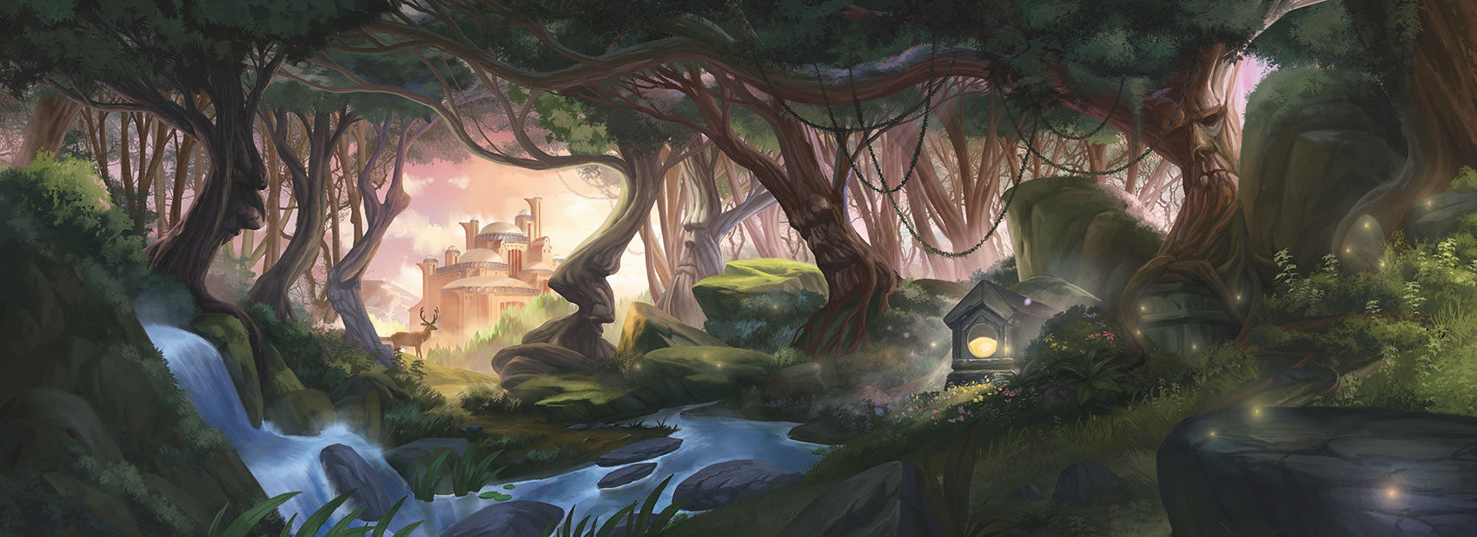](https://media.dndbeyond.com/compendium-images/phb/MKDHZ1nxSXDDLOw2/05-009.guide.jpg)

**Ability Scores:** Dexterity, Constitution, Wisdom

**Feat:** Magic Initiate (Druid) (see [chapter 5](https://www.dndbeyond.com/sources/dnd/phb-2024/feats#MagicInitiate))

**Skill Proficiencies:** **[Stealth](https://www.dndbeyond.com/sources/dnd/free-rules/playing-the-game" \l "Skills)** and **[Survival](https://www.dndbeyond.com/sources/dnd/free-rules/playing-the-game" \l "Skills)**

**Tool Proficiency:** Cartographer’s Tools

**Equipment:** *Choose A or B:* (A) **[Shortbow](https://www.dndbeyond.com/equipment/17-shortbow)**, 20 [**Arrows**](https://www.dndbeyond.com/equipment/508-arrows), [**Cartographer’s Tools**](https://www.dndbeyond.com/equipment/413-cartographers-tools), [**Bedroll**](https://www.dndbeyond.com/equipment/420-bedroll), [**Quiver**](https://www.dndbeyond.com/equipment/407-quiver), [**Tent**](https://www.dndbeyond.com/equipment/433-tent), [**Traveler’s Clothes**](https://www.dndbeyond.com/equipment/541-travelers-clothes), 3 GP; or (B) 50 GP

You came of age outdoors, far from settled lands. Your home was anywhere you chose to spread your bedroll. There are wonders in the wilderness—strange monsters, pristine forests and streams, overgrown ruins of great halls once trod by giants—and you learned to fend for yourself as you explored them. From time to time, you guided friendly nature priests who instructed you in the fundamentals of channeling the magic of the wild.

Hermit

**PEDRO CARDOSO**[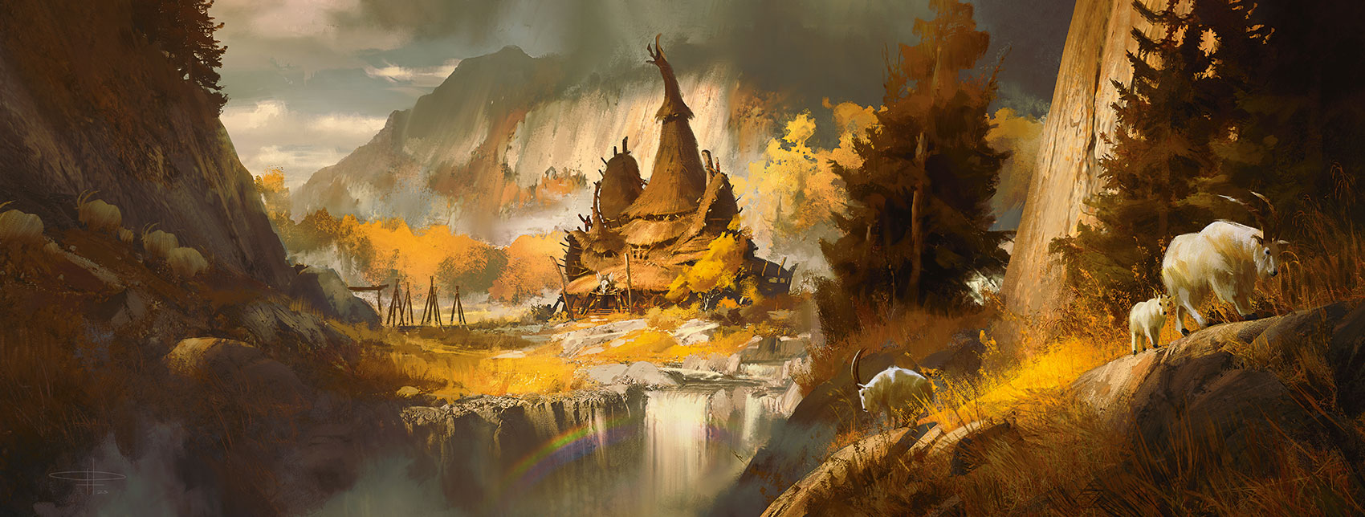](https://media.dndbeyond.com/compendium-images/phb/MKDHZ1nxSXDDLOw2/05-010.hermit.jpg)

**Ability Scores:** Constitution, Wisdom, Charisma

**Feat:** Healer (see [chapter 5](https://www.dndbeyond.com/sources/dnd/phb-2024/feats" \l "Healer))

**Skill Proficiencies:** [**Medicine**](https://www.dndbeyond.com/sources/dnd/free-rules/playing-the-game#Skills) and [**Religion**](https://www.dndbeyond.com/sources/dnd/free-rules/playing-the-game#Skills)

**Tool Proficiency:** Herbalism Kit

**Equipment:** *Choose A or B:* (A) [**Quarterstaff**](https://www.dndbeyond.com/equipment/12-quarterstaff), [**Herbalism Kit**](https://www.dndbeyond.com/equipment/460-herbalism-kit), [**Bedroll**](https://www.dndbeyond.com/equipment/420-bedroll), [**Book**](https://www.dndbeyond.com/equipment/439-book) (philosophy), [**Lamp**](https://www.dndbeyond.com/equipment/496-lamp), [**Oil**](https://www.dndbeyond.com/equipment/393-oil) (3 flasks), [**Traveler’s Clothes**](https://www.dndbeyond.com/equipment/541-travelers-clothes), 16 GP; or (B) 50 GP

You spent your early years secluded in a hut or monastery located well beyond the outskirts of the nearest settlement. In those days, your only companions were the creatures of the forest and those who would occasionally visit to bring news of the outside world and supplies. The solitude allowed you to spend many hours pondering the mysteries of creation.

Merchant

**KAMILA SZUTENBERG**[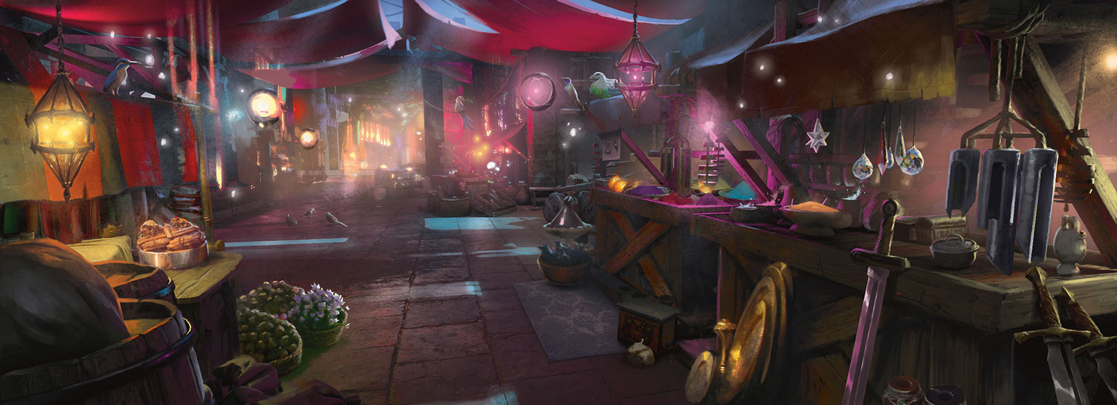](https://media.dndbeyond.com/compendium-images/phb/MKDHZ1nxSXDDLOw2/05-011.merchant.jpg)

**Ability Scores:** Constitution, Intelligence, Charisma

**Feat:** Lucky (see [chapter 5](https://www.dndbeyond.com/sources/dnd/phb-2024/feats#Lucky))

**Skill Proficiencies:** [**Animal Handling**](https://www.dndbeyond.com/sources/dnd/free-rules/playing-the-game#Skills) and [**Persuasion**](https://www.dndbeyond.com/sources/dnd/free-rules/playing-the-game#Skills)

**Tool Proficiency:** Navigator’s Tools

**Equipment:** *Choose A or B:* (A) [**Navigator’s Tools**](https://www.dndbeyond.com/equipment/488-navigators-tools), 2 [**Pouches**](https://www.dndbeyond.com/equipment/403-pouch), [**Traveler’s Clothes**](https://www.dndbeyond.com/equipment/541-travelers-clothes), 22 GP; or (B) 50 GP

You were apprenticed to a trader, caravan master, or shopkeeper, learning the fundamentals of commerce. You traveled broadly, and you earned a living by buying and selling the raw materials artisans need to practice their craft or finished works from such crafters. You might have transported goods from one place to another (by ship, wagon, or caravan) or bought them from traveling traders and sold them in your own shop.

Noble

**NOOR RAHMAN**[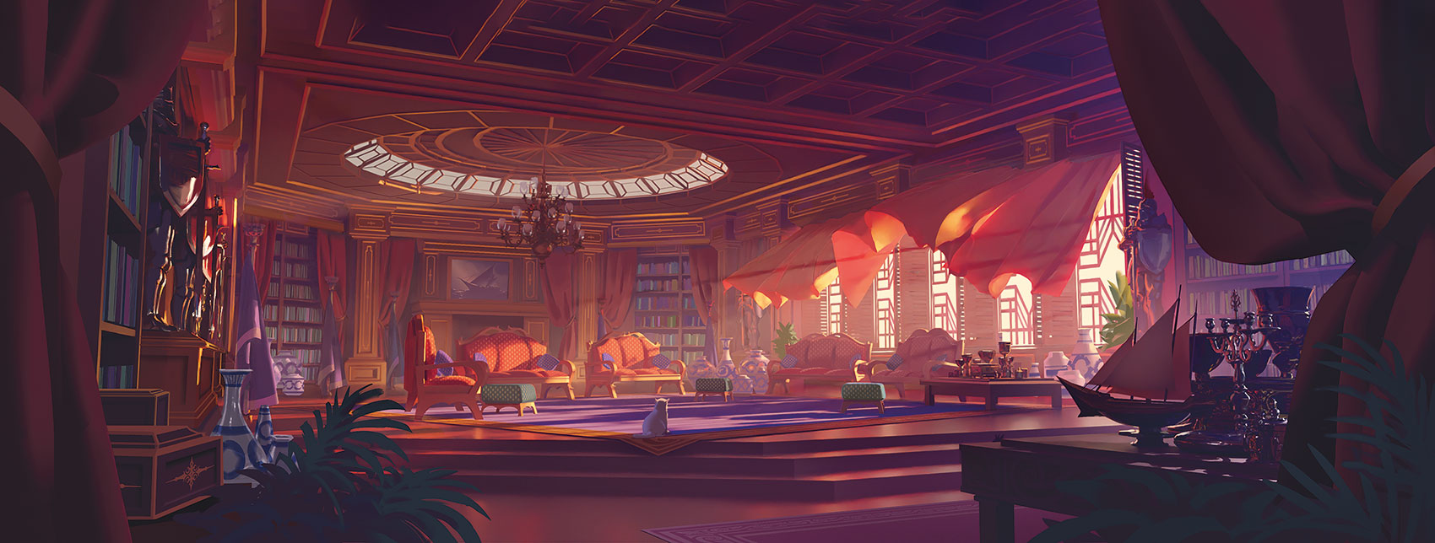](https://media.dndbeyond.com/compendium-images/phb/MKDHZ1nxSXDDLOw2/05-012.noble.jpg)

**Ability Scores:** Strength, Intelligence, Charisma

**Feat:** Skilled (see [chapter 5](https://www.dndbeyond.com/sources/dnd/phb-2024/feats" \l "Skilled))

**Skill Proficiencies:** [**History**](https://www.dndbeyond.com/sources/dnd/free-rules/playing-the-game#Skills) and [**Persuasion**](https://www.dndbeyond.com/sources/dnd/free-rules/playing-the-game#Skills)

**Tool Proficiency:** *Choose one kind of Gaming Set* (see [chapter 6](https://www.dndbeyond.com/sources/dnd/phb-2024/equipment#GamingSetVaries))

**Equipment:** *Choose A or B:* (A) Gaming Set (same as above), [**Fine Clothes**](https://www.dndbeyond.com/equipment/539-fine-clothes), [**Perfume**](https://www.dndbeyond.com/equipment/396-perfume), 29 GP; or (B) 50 GP

You were raised in a castle, surrounded by wealth, power, and privilege. Your family of minor aristocrats ensured that you received a first-class education, some of which you appreciated and some of which you resented. Your time in the castle, especially the many hours you spent observing your family at court, also taught you a great deal about leadership.

Sage

**LIXIN YIN**[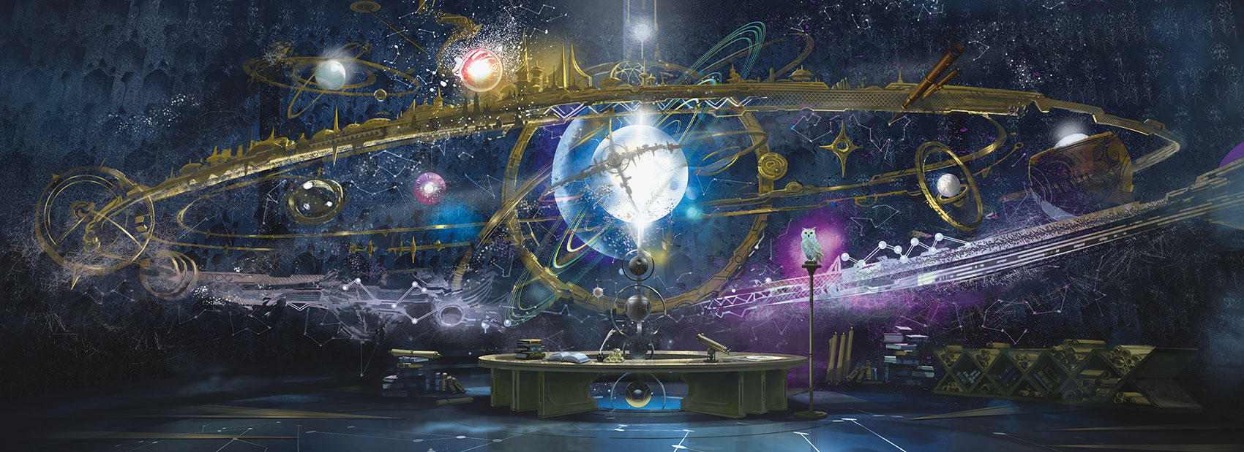](https://media.dndbeyond.com/compendium-images/phb/MKDHZ1nxSXDDLOw2/05-013.sage.jpg)

**Ability Scores:** Constitution, Intelligence, Wisdom

**Feat:** Magic Initiate (Wizard) (see [chapter 5](https://www.dndbeyond.com/sources/dnd/phb-2024/feats#MagicInitiate))

**Skill Proficiencies:** **[Arcana](https://www.dndbeyond.com/sources/dnd/free-rules/playing-the-game" \l "Skills)** and [**History**](https://www.dndbeyond.com/sources/dnd/free-rules/playing-the-game#Skills)

**Tool Proficiency:** Calligrapher’s Supplies

**Equipment:** *Choose A or B:* (A) [**Quarterstaff**](https://www.dndbeyond.com/equipment/12-quarterstaff), [**Calligrapher’s Supplies**](https://www.dndbeyond.com/equipment/404-calligraphers-supplies), [**Book**](https://www.dndbeyond.com/equipment/439-book) (history), [**Parchment**](https://www.dndbeyond.com/equipment/395-parchment) (8 sheets), [**Robe**](https://www.dndbeyond.com/equipment/412-robe), 8 GP; or (B) 50 GP

You spent your formative years traveling between manors and monasteries, performing various odd jobs and services in exchange for access to their libraries. You whiled away many a long evening studying books and scrolls, learning the lore of the multiverse—even the rudiments of magic—and your mind yearns for more.

Sailor

**NOOR RAHMAN**[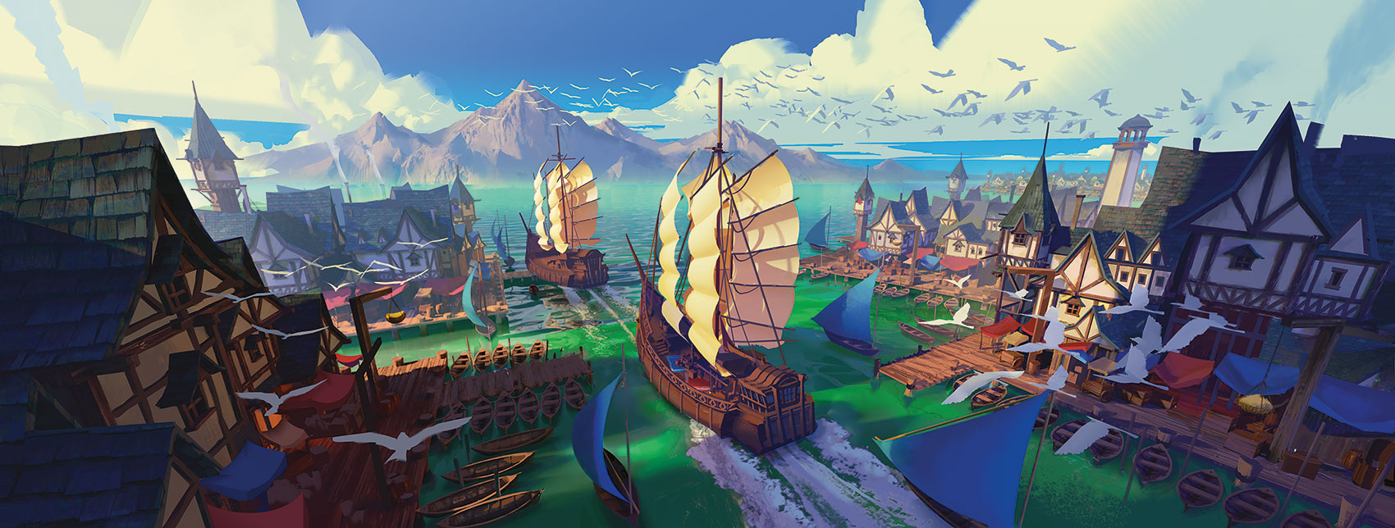](https://media.dndbeyond.com/compendium-images/phb/MKDHZ1nxSXDDLOw2/05-014.sailor.jpg)

**Ability Scores:** Strength, Dexterity, Wisdom

**Feat:** Tavern Brawler (see [chapter 5](https://www.dndbeyond.com/sources/dnd/phb-2024/feats#TavernBrawler))

**Skill Proficiencies:** **[Acrobatics](https://www.dndbeyond.com/sources/dnd/free-rules/playing-the-game" \l "Skills)** and **[Perception](https://www.dndbeyond.com/sources/dnd/free-rules/playing-the-game" \l "Skills)**

**Tool Proficiency:** Navigator’s Tools

**Equipment:** *Choose A or B:* (A) [**Dagger**](https://www.dndbeyond.com/equipment/3-dagger), [**Navigator’s Tools**](https://www.dndbeyond.com/equipment/488-navigators-tools), [**Rope**](https://www.dndbeyond.com/equipment/415-rope), [**Traveler’s Clothes**](https://www.dndbeyond.com/equipment/541-travelers-clothes), 20 GP; or (B) 50 GP

You lived as a seafarer, wind at your back and decks swaying beneath your feet. You’ve perched on barstools in more ports of call than you can remember, faced mighty storms, and swapped stories with folk who live beneath the waves.

Scribe

**KAMILA SZUTENBERG**[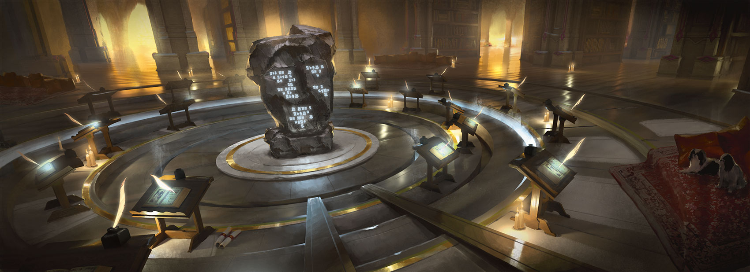](https://media.dndbeyond.com/compendium-images/phb/MKDHZ1nxSXDDLOw2/05-015.scribe.jpg)

**Ability Scores:** Dexterity, Intelligence, Wisdom

**Feat:** Skilled (see [chapter 5](https://www.dndbeyond.com/sources/dnd/phb-2024/feats" \l "Skilled))

**Skill Proficiencies:** [**Investigation**](https://www.dndbeyond.com/sources/dnd/free-rules/playing-the-game#Skills) and [**Perception**](https://www.dndbeyond.com/sources/dnd/free-rules/playing-the-game#Skills)

**Tool Proficiency:** Calligrapher’s Supplies

**Equipment:** *Choose A or B:* (A) [**Calligrapher’s Supplies**](https://www.dndbeyond.com/equipment/404-calligraphers-supplies), [**Fine Clothes**](https://www.dndbeyond.com/equipment/539-fine-clothes), [**Lamp**](https://www.dndbeyond.com/equipment/496-lamp), [**Oil**](https://www.dndbeyond.com/equipment/393-oil) (3 flasks), [**Parchment**](https://www.dndbeyond.com/equipment/395-parchment) (12 sheets), 23 GP; or (B) 50 GP

You spent formative years in a scriptorium, a monastery dedicated to the preservation of knowledge, or a government agency, where you learned to write with a clear hand and produce finely written texts. Perhaps you scribed government documents or copied tomes of literature. You might have some skill as a writer of poetry, narrative, or scholarly research. Above all, you have a careful attention to detail, helping you avoid introducing mistakes to the documents you copy and create.

Soldier

**FABIÀ SANS**[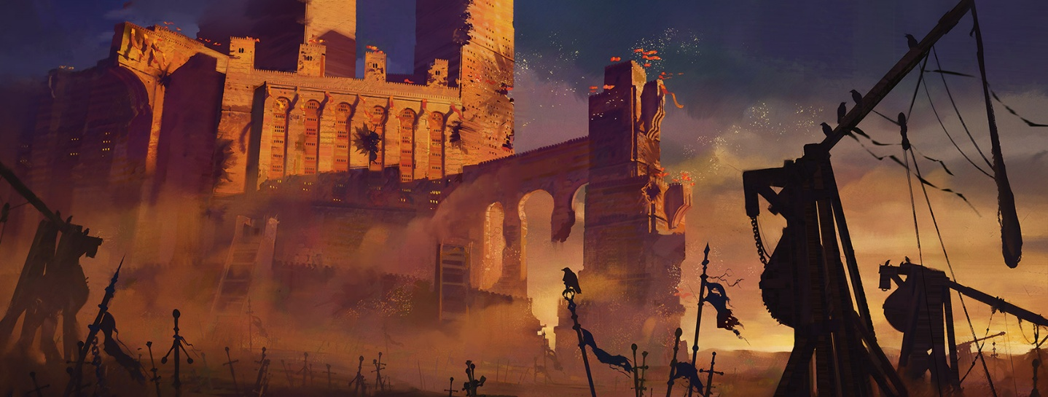](https://media.dndbeyond.com/compendium-images/phb/MKDHZ1nxSXDDLOw2/05-016.soldier.jpg)

**Ability Scores:** Strength, Dexterity, Constitution

**Feat:** Savage Attacker (see [chapter 5](https://www.dndbeyond.com/sources/dnd/phb-2024/feats#SavageAttacker))

**Skill Proficiencies:** **[Athletics](https://www.dndbeyond.com/sources/dnd/free-rules/playing-the-game" \l "Skills)** and **[Intimidation](https://www.dndbeyond.com/sources/dnd/free-rules/playing-the-game" \l "Skills)**

**Tool Proficiency:** *Choose one kind of Gaming Set* (see [chapter 6](https://www.dndbeyond.com/sources/dnd/phb-2024/equipment#GamingSetVaries))

**Equipment:** *Choose A or B:* (A) [**Spear**](https://www.dndbeyond.com/equipment/14-spear), **[Shortbow](https://www.dndbeyond.com/equipment/17-shortbow)**, 20 [**Arrows**](https://www.dndbeyond.com/equipment/508-arrows), Gaming Set (same as above), [**Healer’s Kit**](https://www.dndbeyond.com/equipment/515-healers-kit), [**Quiver**](https://www.dndbeyond.com/equipment/407-quiver), [**Traveler’s Clothes**](https://www.dndbeyond.com/equipment/541-travelers-clothes), 14 GP; or (B) 50 GP

You began training for war as soon as you reached adulthood and carry precious few memories of life before you took up arms. Battle is in your blood. Sometimes you catch yourself reflexively performing the basic fighting exercises you learned first. Eventually, you put that training to use on the battlefield, protecting the realm by waging war.

Wayfarer

**JONAS DE RO**[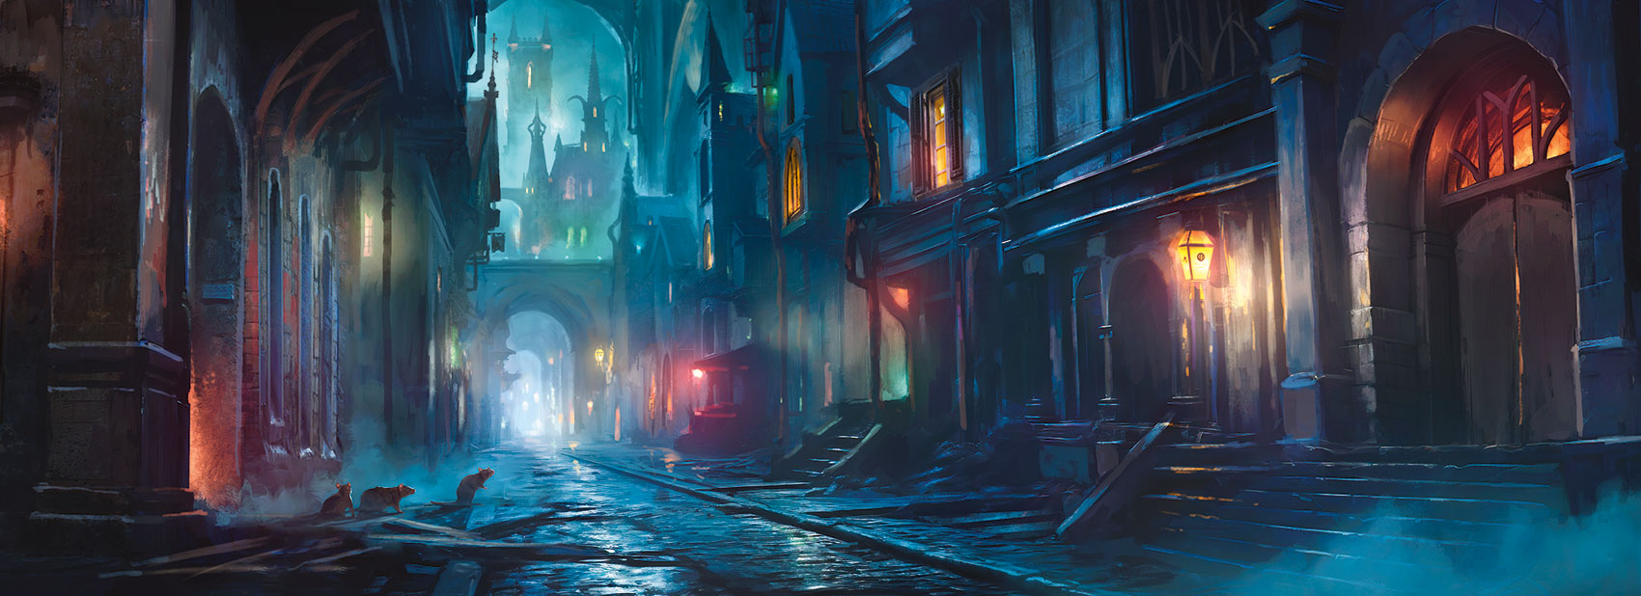](https://media.dndbeyond.com/compendium-images/phb/MKDHZ1nxSXDDLOw2/05-017.wayfarer.jpg)

**Ability Scores:** Dexterity, Wisdom, Charisma

**Feat:** Lucky (see [chapter 5](https://www.dndbeyond.com/sources/dnd/phb-2024/feats" \l "Lucky))

**Skill Proficiencies:** [**Insight**](https://www.dndbeyond.com/sources/dnd/free-rules/playing-the-game#Skills) and [**Stealth**](https://www.dndbeyond.com/sources/dnd/free-rules/playing-the-game#Skills)

**Tool Proficiency:** Thieves’ Tools

**Equipment:** *Choose A or B:* (A) 2 [**Daggers**](https://www.dndbeyond.com/equipment/3-dagger), [**Thieves’ Tools**](https://www.dndbeyond.com/equipment/495-thieves-tools), Gaming Set (any), [**Bedroll**](https://www.dndbeyond.com/equipment/420-bedroll), 2 [**Pouches**](https://www.dndbeyond.com/equipment/403-pouch), [**Traveler’s Clothes**](https://www.dndbeyond.com/equipment/541-travelers-clothes), 16 GP; or (B) 50 GP

You grew up on the streets surrounded by similarly ill-fated castoffs, a few of them friends and a few of them rivals. You slept where you could and did odd jobs for food. At times, when the hunger became unbearable, you resorted to theft. Still, you never lost your pride and never abandoned hope. Fate is not yet finished with you.

Species Descriptions

Ten species are presented in this section in alphabetical order: [Aasimar](https://www.dndbeyond.com/sources/dnd/phb-2024/character-origins#Aasimar), [Dragonborn](https://www.dndbeyond.com/sources/dnd/phb-2024/character-origins#Dragonborn), [Dwarf](https://www.dndbeyond.com/sources/dnd/phb-2024/character-origins#Dwarf), [Elf](https://www.dndbeyond.com/sources/dnd/phb-2024/character-origins#Elf), [Gnome](https://www.dndbeyond.com/sources/dnd/phb-2024/character-origins#Gnome), [Goliath](https://www.dndbeyond.com/sources/dnd/phb-2024/character-origins#Goliath), [Halfling](https://www.dndbeyond.com/sources/dnd/phb-2024/character-origins#Halfling), [Human](https://www.dndbeyond.com/sources/dnd/phb-2024/character-origins#Human), [Orc](https://www.dndbeyond.com/sources/dnd/phb-2024/character-origins#Orc), and [Tiefling](https://www.dndbeyond.com/sources/dnd/phb-2024/character-origins#Tiefling).

Aasimar

**ALDO DOMINGUEZ**[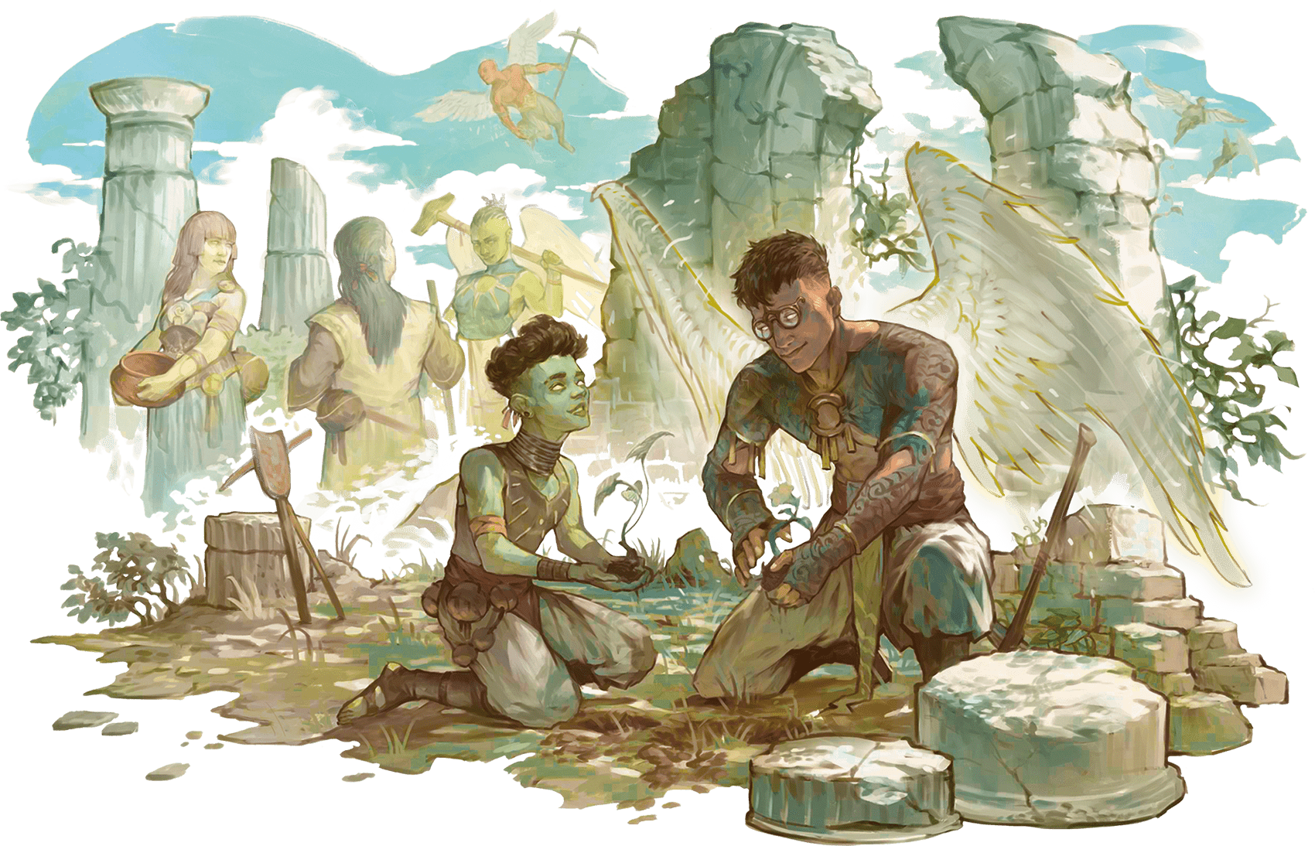](https://media.dndbeyond.com/compendium-images/phb/MKDHZ1nxSXDDLOw2/05-018.aasimar.png)

Aasimar (pronounced AH-sih-mar) are mortals who carry a spark of the Upper Planes within their souls. Whether descended from an angelic being or infused with celestial power, they can fan that spark to bring light, healing, and heavenly fury.

Aasimar can arise among any population of mortals. They resemble their parents, but they live for up to 160 years and have features that hint at their celestial heritage, such as metallic freckles, luminous eyes, a halo, or the skin color of an angel (silver, opalescent green, or coppery red). These features start subtle and become obvious when the aasimar learns to reveal their full celestial nature.

**Aasimar Traits**

**Creature Type:** Humanoid

**Size:** Medium (about 4–7 feet tall) or Small (about 2–4 feet tall), chosen when you select this species

**Speed:** 30 feet

As an Aasimar, you have these special traits.

***Celestial Resistance.*** You have Resistance to Necrotic damage and Radiant damage.

***Darkvision.*** You have [**Darkvision**](https://www.dndbeyond.com/sources/dnd/free-rules/rules-glossary#Darkvision) with a range of 60 feet.

***Healing Hands.*** As a [**Magic**](https://www.dndbeyond.com/sources/dnd/free-rules/rules-glossary#MagicAction) action, you touch a creature and roll a number of d4s equal to your Proficiency Bonus. The creature regains a number of Hit Points equal to the total rolled. Once you use this trait, you can’t use it again until you finish a [**Long Rest**](https://www.dndbeyond.com/sources/dnd/free-rules/rules-glossary#LongRest).

***Light Bearer.*** You know the [***Light***](https://www.dndbeyond.com/spells/2618996-light) cantrip. Charisma is your spellcasting ability for it.

***Celestial Revelation.*** When you reach character level 3, you can transform as a Bonus Action using one of the options below (choose the option each time you transform). The transformation lasts for 1 minute or until you end it (no action required). Once you transform, you can’t do so again until you finish a [**Long Rest**](https://www.dndbeyond.com/sources/dnd/free-rules/rules-glossary#LongRest).

Once on each of your turns before the transformation ends, you can deal extra damage to one target when you deal damage to it with an attack or a spell. The extra damage equals your Proficiency Bonus, and the extra damage’s type is either Necrotic for Necrotic Shroud or Radiant for Heavenly Wings and Inner Radiance.

Here are the transformation options:

**Heavenly Wings.** Two spectral wings sprout from your back temporarily. Until the transformation ends, you have a Fly Speed equal to your Speed.

**Inner Radiance.** Searing light temporarily radiates from your eyes and mouth. For the duration, you shed [**Bright Light**](https://www.dndbeyond.com/sources/dnd/free-rules/rules-glossary#BrightLight) in a 10-foot radius and [**Dim Light**](https://www.dndbeyond.com/sources/dnd/free-rules/rules-glossary#DimLight) for an additional 10 feet, and at the end of each of your turns, each creature within 10 feet of you takes Radiant damage equal to your Proficiency Bonus.

**Necrotic Shroud.** Your eyes briefly become pools of darkness, and flightless wings sprout from your back temporarily. Creatures other than your allies within 10 feet of you must succeed on a Charisma saving throw (DC 8 plus your Charisma modifier and Proficiency Bonus) or have the [**Frightened**](https://www.dndbeyond.com/sources/dnd/free-rules/rules-glossary#FrightenedCondition) condition until the end of your next turn.

Dragonborn

**DAVID AUDEN NASH**[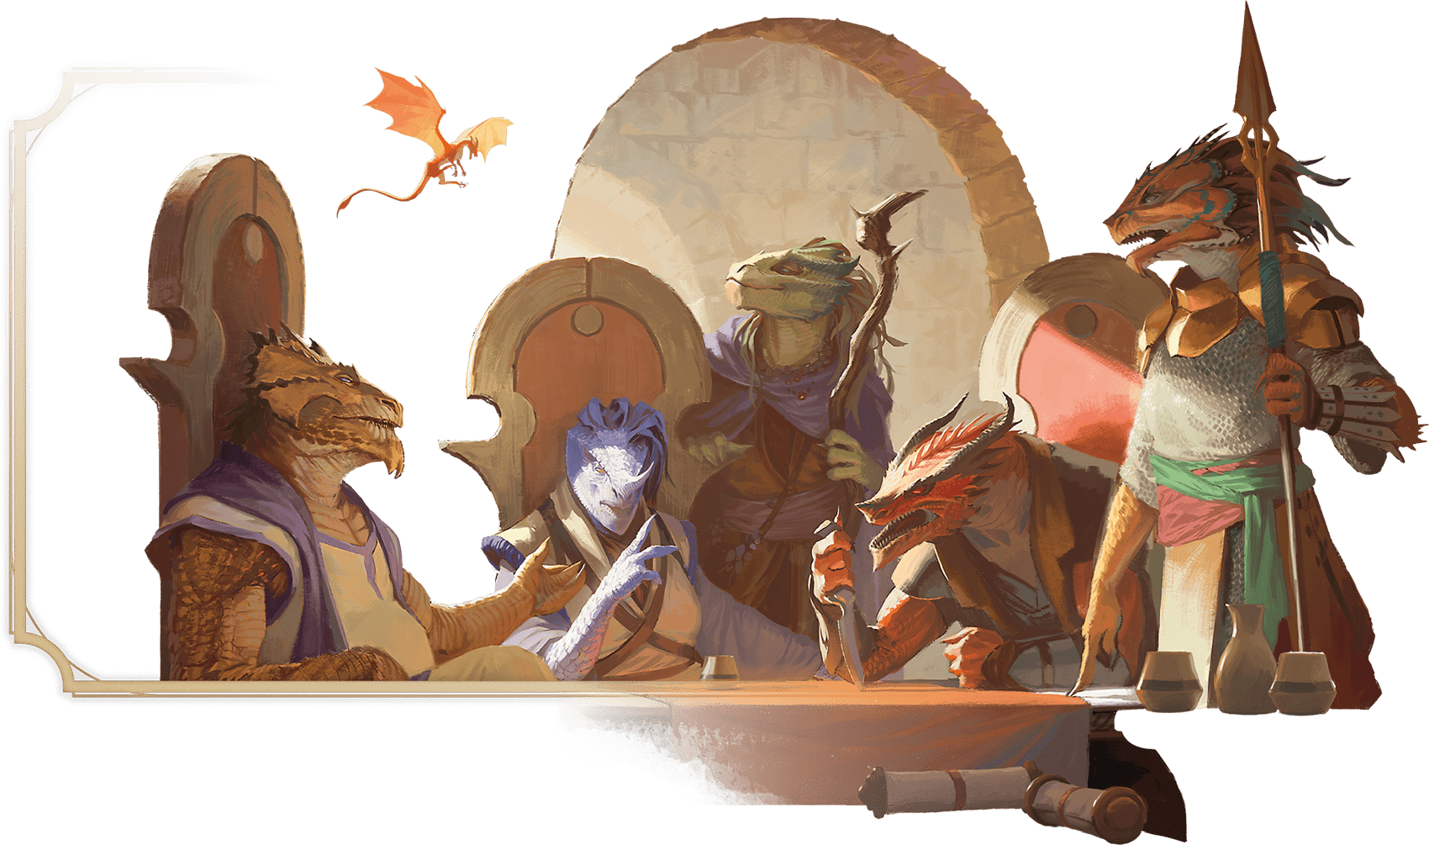](https://media.dndbeyond.com/compendium-images/phb/MKDHZ1nxSXDDLOw2/05-019.dragonborn.png)

The ancestors of dragonborn hatched from the eggs of chromatic and metallic dragons. One story holds that these eggs were blessed by the dragon gods Bahamut and Tiamat, who wanted to populate the multiverse with people created in their image. Another story claims that dragons created the first dragonborn without the gods’ blessings. Whatever their origin, dragonborn have made homes for themselves on the Material Plane.

Dragonborn look like wingless, bipedal dragons—scaly, bright-eyed, and thick-boned with horns on their heads—and their coloration and other features are reminiscent of their draconic ancestors.

**Dragonborn Traits**

**Creature Type:** Humanoid

**Size:** Medium (about 5–7 feet tall)

**Speed:** 30 feet

As a Dragonborn, you have these special traits.

***Draconic Ancestry.*** Your lineage stems from a dragon progenitor. Choose the kind of dragon from the Draconic Ancestors table. Your choice affects your Breath Weapon and Damage Resistance traits as well as your appearance.

| **Draconic Ancestors** | |
| --- | --- |
| **Dragon** | **Damage Type** |
| Black | Acid |
| Blue | Lightning |
| Brass | Fire |
| Bronze | Lightning |
| Copper | Acid |
| Gold | Fire |
| Green | Poison |
| Red | Fire |
| Silver | Cold |
| White | Cold |

***Breath Weapon.*** When you take the **[Attack](https://www.dndbeyond.com/sources/dnd/free-rules/rules-glossary" \l "AttackAction)** action on your turn, you can replace one of your attacks with an exhalation of magical energy in either a 15-foot [**Cone**](https://www.dndbeyond.com/sources/dnd/free-rules/rules-glossary#ConeAreaofEffect) or a 30-foot [**Line**](https://www.dndbeyond.com/sources/dnd/free-rules/rules-glossary#LineAreaofEffect) that is 5 feet wide (choose the shape each time). Each creature in that area must make a Dexterity saving throw (DC 8 plus your Constitution modifier and Proficiency Bonus). On a failed save, a creature takes 1d10 damage of the type determined by your Draconic Ancestry trait. On a successful save, a creature takes half as much damage. This damage increases by 1d10 when you reach character levels 5 (2d10), 11 (3d10), and 17 (4d10). You can use this Breath Weapon a number of times equal to your Proficiency Bonus, and you regain all expended uses when you finish a [**Long Rest**](https://www.dndbeyond.com/sources/dnd/free-rules/rules-glossary#LongRest).

***Damage Resistance.*** You have Resistance to the damage type determined by your Draconic Ancestry trait.

***Darkvision.*** You have [**Darkvision**](https://www.dndbeyond.com/sources/dnd/free-rules/rules-glossary#Darkvision) with a range of 60 feet.

***Draconic Flight.*** When you reach character level 5, you can channel draconic magic to give yourself temporary flight. As a Bonus Action, you sprout spectral wings on your back that last for 10 minutes or until you retract the wings (no action required) or have the [**Incapacitated**](https://www.dndbeyond.com/sources/dnd/free-rules/rules-glossary#IncapacitatedCondition) condition. During that time, you have a Fly Speed equal to your Speed. Your wings appear to be made of the same energy as your Breath Weapon. Once you use this trait, you can’t use it again until you finish a [**Long Rest**](https://www.dndbeyond.com/sources/dnd/free-rules/rules-glossary#LongRest).

Dwarf

**MIKE PAPE**[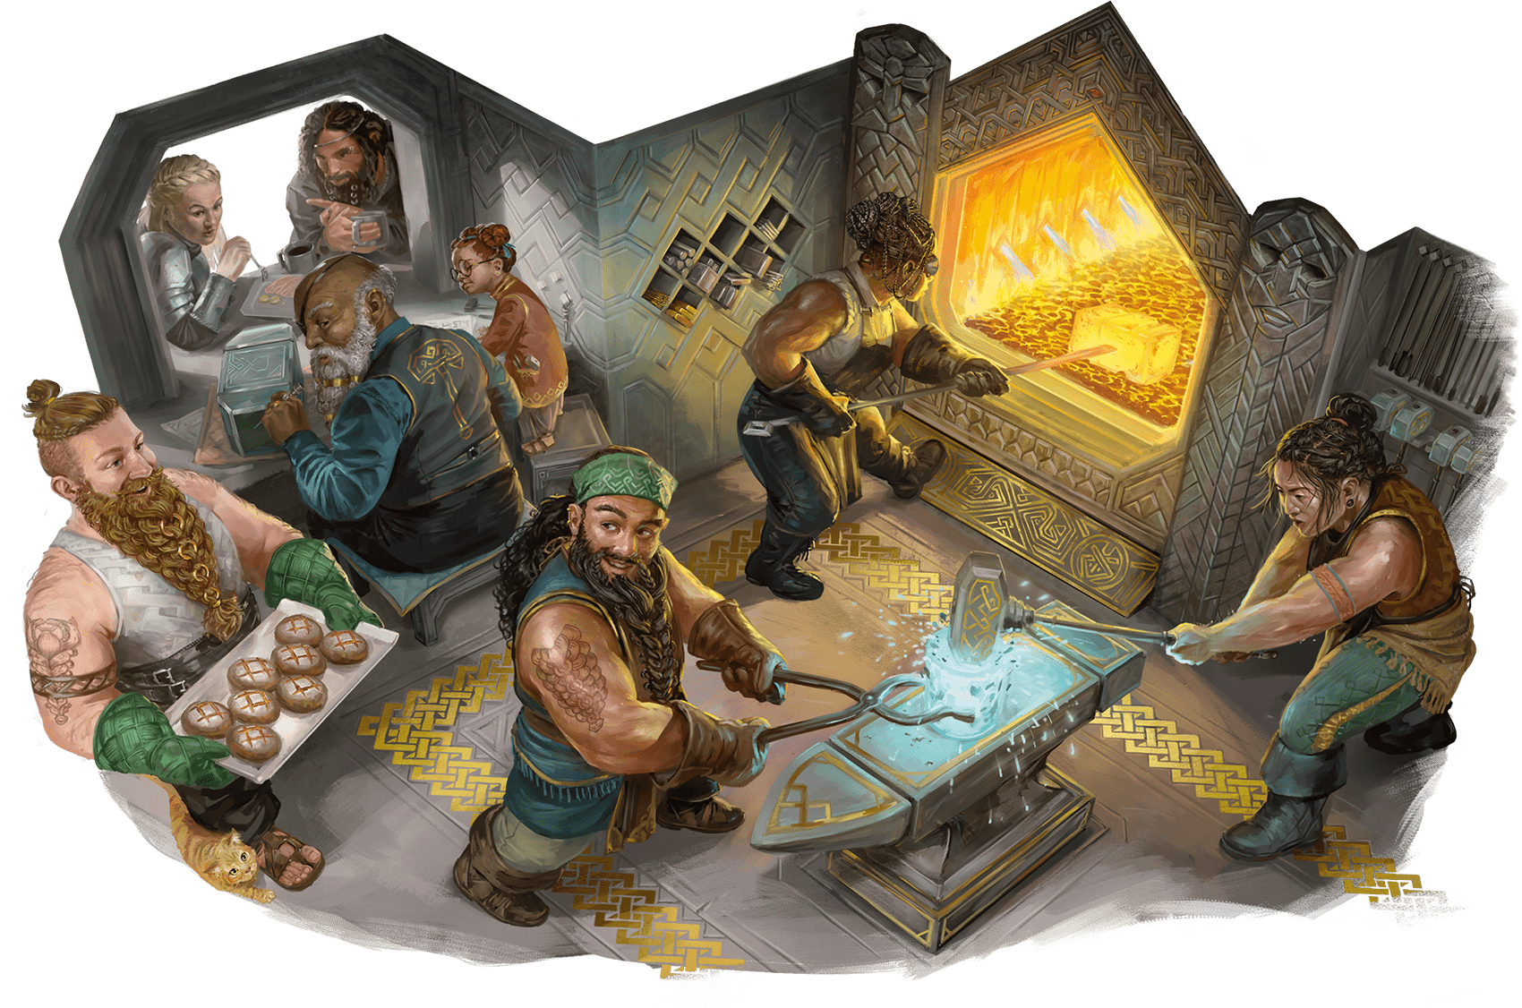](https://media.dndbeyond.com/compendium-images/phb/MKDHZ1nxSXDDLOw2/05-020.dwarf.png)

Dwarves were raised from the earth in the elder days by a deity of the forge. Called by various names on different worlds—Moradin, Reorx, and others—that god gave dwarves an affinity for stone and metal and for living underground. The god also made them resilient like the mountains, with a life span of about 350 years.

Squat and often bearded, the original dwarves carved cities and strongholds into mountainsides and under the earth. Their oldest legends tell of conflicts with the monsters of mountaintops and the Underdark, whether those monsters were towering giants or subterranean horrors. Inspired by those tales, dwarves of any culture often sing of valorous deeds—especially of the little overcoming the mighty.

On some worlds in the multiverse, the first settlements of dwarves were built in hills or mountains, and the families who trace their ancestry to those settlements call themselves hill dwarves or mountain dwarves, respectively. The Greyhawk and Dragonlance settings have such communities.

**Dwarf Traits**

**Creature Type:** Humanoid

**Size:** Medium (about 4–5 feet tall)

**Speed:** 30 feet

As a Dwarf, you have these special traits.

***Darkvision.*** You have [**Darkvision**](https://www.dndbeyond.com/sources/dnd/free-rules/rules-glossary#Darkvision) with a range of 120 feet.

***Dwarven Resilience.*** You have Resistance to Poison damage. You also have [**Advantage**](https://www.dndbeyond.com/sources/dnd/free-rules/rules-glossary#Advantage) on saving throws you make to avoid or end the [**Poisoned**](https://www.dndbeyond.com/sources/dnd/free-rules/rules-glossary#PoisonedCondition) condition.

***Dwarven Toughness.*** Your Hit Point maximum increases by 1, and it increases by 1 again whenever you gain a level.

***Stonecunning.*** As a Bonus Action, you gain **[Tremorsense](https://www.dndbeyond.com/sources/dnd/free-rules/rules-glossary" \l "Tremorsense)** with a range of 60 feet for 10 minutes. You must be on a stone surface or touching a stone surface to use this Tremorsense. The stone can be natural or worked. You can use this Bonus Action a number of times equal to your Proficiency Bonus, and you regain all expended uses when you finish a [**Long Rest**](https://www.dndbeyond.com/sources/dnd/free-rules/rules-glossary#LongRest).

Elf

**MIKE PAPE**[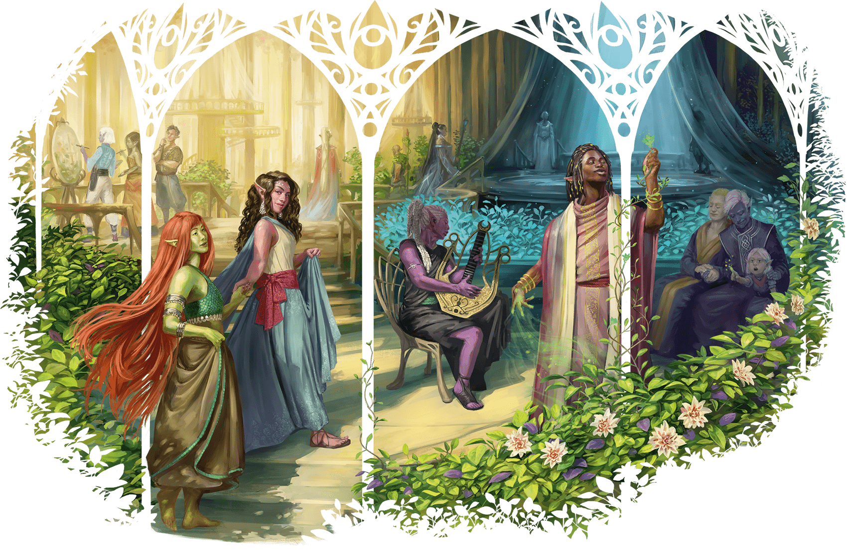](https://media.dndbeyond.com/compendium-images/phb/MKDHZ1nxSXDDLOw2/05-021.elf.png)

Created by the god Corellon, the first elves could change their forms at will. They lost this ability when Corellon cursed them for plotting with the deity Lolth, who tried and failed to usurp Corellon’s dominion. When Lolth was cast into the Abyss, most elves renounced her and earned Corellon’s forgiveness, but that which Corellon had taken from them was lost forever.

No longer able to shape-shift at will, the elves retreated to the Feywild, where their sorrow was deepened by that plane’s influence. Over time, curiosity led many of them to explore other planes of existence, including worlds in the Material Plane.

Elves have pointed ears and lack facial and body hair. They live for around 750 years, and they don’t sleep but instead enter a trance when they need to rest. In that state, they remain aware of their surroundings while immersing themselves in memories and meditations.

An environment subtly transforms elves after they inhabit it for a millennium or more, and it grants them certain kinds of magic. Drow, high elves, and wood elves are examples of elves who have been transformed thus.

**Drow**

Drow typically dwell in the Underdark and have been shaped by it. Some drow individuals and societies avoid the Underdark altogether yet carry its magic. In the Eberron setting, for example, drow dwell in rainforests and cyclopean ruins on the continent of Xen’drik.

**High Elves**

High elves have been infused with the magic of crossings between the Feywild and the Material Plane. On some worlds, high elves refer to themselves by other names. For example, they call themselves sun or moon elves in the Forgotten Realms setting, Silvanesti and Qualinesti in the Dragonlance setting, and Aereni in the Eberron setting.

**Wood Elves**

Wood elves carry the magic of primeval forests within themselves. They are known by many other names, including wild elves, green elves, and forest elves. Grugach are reclusive wood elves of the Greyhawk setting, while the Kagonesti and the Tairnadal are wood elves of the Dragonlance and Eberron settings, respectively.

**JEDD CHEVRIER**[](https://media.dndbeyond.com/compendium-images/phb/MKDHZ1nxSXDDLOw2/05-022.elf-city.png)A ship departs from a city built by high elves

**Elf Traits**

**Creature Type:** Humanoid

**Size:** Medium (about 5–6 feet tall)

**Speed:** 30 feet

As an Elf, you have these special traits.

***Darkvision.*** You have [**Darkvision**](https://www.dndbeyond.com/sources/dnd/free-rules/rules-glossary#Darkvision) with a range of 60 feet.

***Elven Lineage.*** You are part of a lineage that grants you supernatural abilities. Choose a lineage from the [Elven Lineages table](https://www.dndbeyond.com/sources/dnd/phb-2024/character-origins#ElvenLineages). You gain the level 1 benefit of that lineage.

When you reach character levels 3 and 5, you learn a higher-level spell, as shown on the table. You always have that spell prepared. You can cast it once without a spell slot, and you regain the ability to cast it in that way when you finish a [**Long Rest**](https://www.dndbeyond.com/sources/dnd/free-rules/rules-glossary#LongRest). You can also cast the spell using any spell slots you have of the appropriate level. Intelligence, Wisdom, or Charisma is your spellcasting ability for the spells you cast with this trait (choose the ability when you select the lineage).

***Fey Ancestry.*** You have [**Advantage**](https://www.dndbeyond.com/sources/dnd/free-rules/rules-glossary#Advantage) on saving throws you make to avoid or end the [**Charmed**](https://www.dndbeyond.com/sources/dnd/free-rules/rules-glossary#CharmedCondition) condition.

***Keen Senses.*** You have proficiency in the [**Insight**](https://www.dndbeyond.com/sources/dnd/free-rules/playing-the-game#Skills), [**Perception**](https://www.dndbeyond.com/sources/dnd/free-rules/playing-the-game#Skills), or [**Survival**](https://www.dndbeyond.com/sources/dnd/free-rules/playing-the-game#Skills) skill.

***Trance.*** You don’t need to sleep, and magic can’t put you to sleep. You can finish a [**Long Rest**](https://www.dndbeyond.com/sources/dnd/free-rules/rules-glossary#LongRest) in 4 hours if you spend those hours in a trancelike meditation, during which you retain consciousness.

| **Elven Lineages** | | | |
| --- | --- | --- | --- |
| **Lineage** | **Level 1** | **Level 3** | **Level 5** |
| Drow | The range of your [**Darkvision**](https://www.dndbeyond.com/sources/dnd/free-rules/rules-glossary#Darkvision) increases to 120 feet. You also know the [***Dancing Lights***](https://www.dndbeyond.com/spells/2619058-dancing-lights) cantrip. | [***Faerie Fire***](https://www.dndbeyond.com/spells/2618858-faerie-fire) | [***Darkness***](https://www.dndbeyond.com/spells/2619080-darkness) |
| High Elf | You know the [***Prestidigitation***](https://www.dndbeyond.com/spells/2618893-prestidigitation) cantrip. Whenever you finish a [**Long Rest**](https://www.dndbeyond.com/sources/dnd/free-rules/rules-glossary#LongRest), you can replace that cantrip with a different cantrip from the [Wizard spell list](https://www.dndbeyond.com/sources/dnd/phb-2024/character-classes-continued#WizardSpellList). | [***Detect Magic***](https://www.dndbeyond.com/spells/2619097-detect-magic) | [***Misty Step***](https://www.dndbeyond.com/spells/2619133-misty-step) |
| Wood Elf | Your Speed increases to 35 feet. You also know the [***Druidcraft***](https://www.dndbeyond.com/spells/2619158-druidcraft) cantrip. | [***Longstrider***](https://www.dndbeyond.com/spells/2619004-longstrider) | [***Pass without Trace***](https://www.dndbeyond.com/spells/2618849-pass-without-trace) |

Gnome

**ERIC BELISLE**[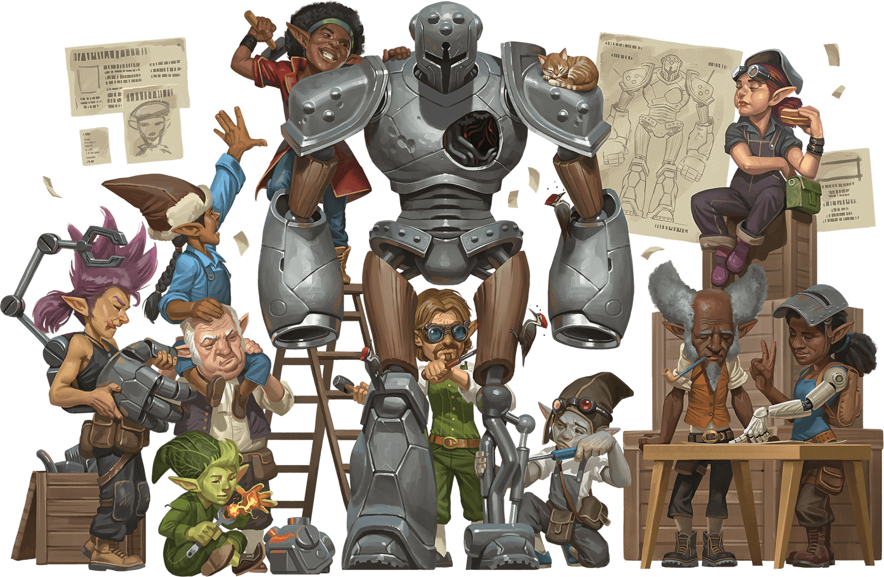](https://media.dndbeyond.com/compendium-images/phb/MKDHZ1nxSXDDLOw2/05-023.gnome.png)

Gnomes are magical folk created by gods of invention, illusions, and life underground. The earliest gnomes were seldom seen by other folk due to the gnomes’ secretive nature and their propensity for living in forests and burrows. What they lacked in size, they made up for in cleverness. They confounded predators with traps and labyrinthine tunnels. They also learned magic from gods like Garl Glittergold, Baervan Wildwanderer, and Baravar Cloakshadow, who visited them in disguise. That magic eventually created the lineages of forest gnomes and rock gnomes.

Gnomes are petite folk with big eyes and pointed ears, who live around 425 years. Many gnomes like the feeling of a roof over their head, even if that “roof” is nothing more than a hat.

**Gnome Traits**

**Creature Type:** Humanoid

**Size:** Small (about 3–4 feet tall)

**Speed:** 30 feet

As a Gnome, you have these special traits.

***Darkvision.*** You have [**Darkvision**](https://www.dndbeyond.com/sources/dnd/free-rules/rules-glossary#Darkvision) with a range of 60 feet.

***Gnomish Cunning.*** You have [**Advantage**](https://www.dndbeyond.com/sources/dnd/free-rules/rules-glossary#Advantage) on Intelligence, Wisdom, and Charisma saving throws.

***Gnomish Lineage.*** You are part of a lineage that grants you supernatural abilities. Choose one of the following options; whichever one you choose, Intelligence, Wisdom, or Charisma is your spellcasting ability for the spells you cast with this trait (choose the ability when you select the lineage):

**Forest Gnome.** You know the [***Minor Illusion***](https://www.dndbeyond.com/spells/2619039-minor-illusion) cantrip. You also always have the [***Speak with Animals***](https://www.dndbeyond.com/spells/2619059-speak-with-animals) spell prepared. You can cast it without a spell slot a number of times equal to your Proficiency Bonus, and you regain all expended uses when you finish a [**Long Rest**](https://www.dndbeyond.com/sources/dnd/free-rules/rules-glossary#LongRest). You can also use any spell slots you have to cast the spell.

**Rock Gnome.** You know the [***Mending***](https://www.dndbeyond.com/spells/2619033-mending) and [***Prestidigitation***](https://www.dndbeyond.com/spells/2618893-prestidigitation) cantrips. In addition, you can spend 10 minutes casting *Prestidigitation* to create a Tiny clockwork device (AC 5, 1 HP), such as a toy, fire starter, or music box. When you create the device, you determine its function by choosing one effect from *Prestidigitation*; the device produces that effect whenever you or another creature takes a Bonus Action to activate it with a touch. If the chosen effect has options within it, you choose one of those options for the device when you create it. For example, if you choose the spell’s ignite-extinguish effect, you determine whether the device ignites or extinguishes fire; the device doesn’t do both. You can have three such devices in existence at a time, and each falls apart 8 hours after its creation or when you dismantle it with a touch as a [**Utilize**](https://www.dndbeyond.com/sources/dnd/free-rules/rules-glossary#UtilizeAction) action.

Goliath

**HINCHEL OR**[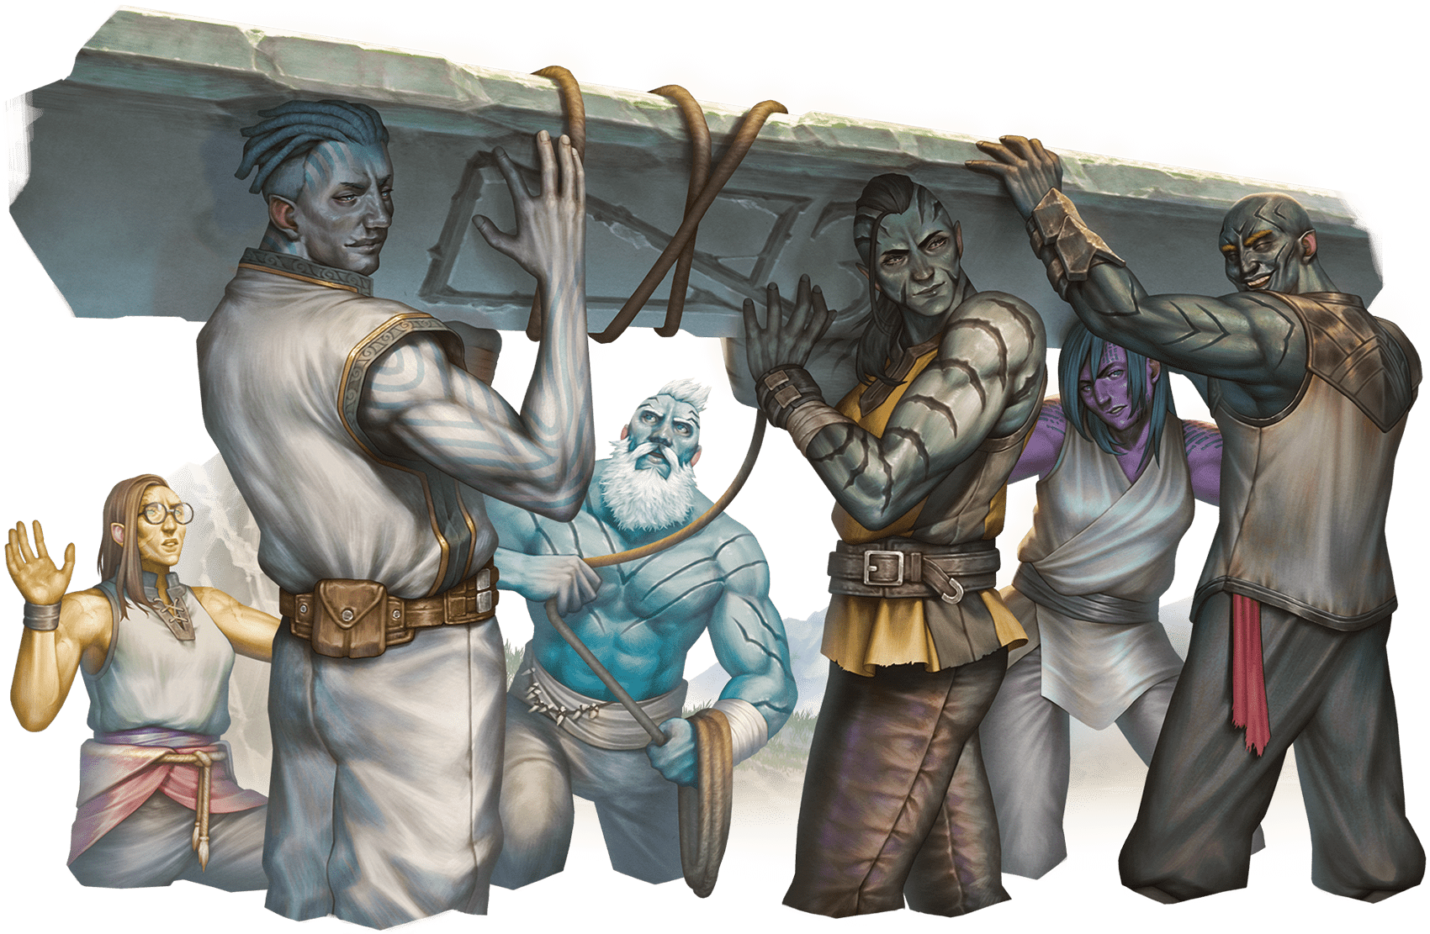](https://media.dndbeyond.com/compendium-images/phb/MKDHZ1nxSXDDLOw2/05-024.goliath.png)

Towering over most folk, goliaths are distant descendants of giants. Each goliath bears the favors of the first giants—favors that manifest in various supernatural boons, including the ability to quickly grow and temporarily approach the height of goliaths’ gigantic kin.

Goliaths have physical characteristics that are reminiscent of the giants in their family lines. For example, some goliaths look like stone giants, while others resemble fire giants. Whatever giants they count as kin, goliaths have forged their own path in the multiverse—unencumbered by the internecine conflicts that have ravaged giantkind for ages—and seek heights above those reached by their ancestors.

**Goliath Traits**

**Creature Type:** Humanoid

**Size:** Medium (about 7–8 feet tall)

**Speed:** 35 feet

As a Goliath, you have these special traits.

***Giant Ancestry.*** You are descended from Giants. Choose one of the following benefits—a supernatural boon from your ancestry; you can use the chosen benefit a number of times equal to your Proficiency Bonus, and you regain all expended uses when you finish a [**Long Rest**](https://www.dndbeyond.com/sources/dnd/free-rules/rules-glossary#LongRest):

**Cloud’s Jaunt (Cloud Giant).** As a Bonus Action, you magically teleport up to 30 feet to an unoccupied space you can see.

**Fire’s Burn (Fire Giant).** When you hit a target with an attack roll and deal damage to it, you can also deal 1d10 Fire damage to that target.

**Frost’s Chill (Frost Giant).** When you hit a target with an attack roll and deal damage to it, you can also deal 1d6 Cold damage to that target and reduce its Speed by 10 feet until the start of your next turn.

**Hill’s Tumble (Hill Giant).** When you hit a Large or smaller creature with an attack roll and deal damage to it, you can give that target the [**Prone**](https://www.dndbeyond.com/sources/dnd/free-rules/rules-glossary#ProneCondition) condition.

**Stone’s Endurance (Stone Giant).** When you take damage, you can take a Reaction to roll 1d12. Add your Constitution modifier to the number rolled and reduce the damage by that total.

**Storm’s Thunder (Storm Giant).** When you take damage from a creature within 60 feet of you, you can take a Reaction to deal 1d8 Thunder damage to that creature.

***Large Form.*** Starting at character level 5, you can change your size to Large as a Bonus Action if you’re in a big enough space. This transformation lasts for 10 minutes or until you end it (no action required). For that duration, you have [**Advantage**](https://www.dndbeyond.com/sources/dnd/free-rules/rules-glossary#Advantage) on Strength checks, and your Speed increases by 10 feet. Once you use this trait, you can’t use it again until you finish a [**Long Rest**](https://www.dndbeyond.com/sources/dnd/free-rules/rules-glossary#LongRest).

***Powerful Build.*** You have [**Advantage**](https://www.dndbeyond.com/sources/dnd/free-rules/rules-glossary#Advantage) on any ability check you make to end the [**Grappled**](https://www.dndbeyond.com/sources/dnd/free-rules/rules-glossary#GrappledCondition) condition. You also count as one size larger when determining your carrying capacity.

Halfling

**JANE KATSUBO**[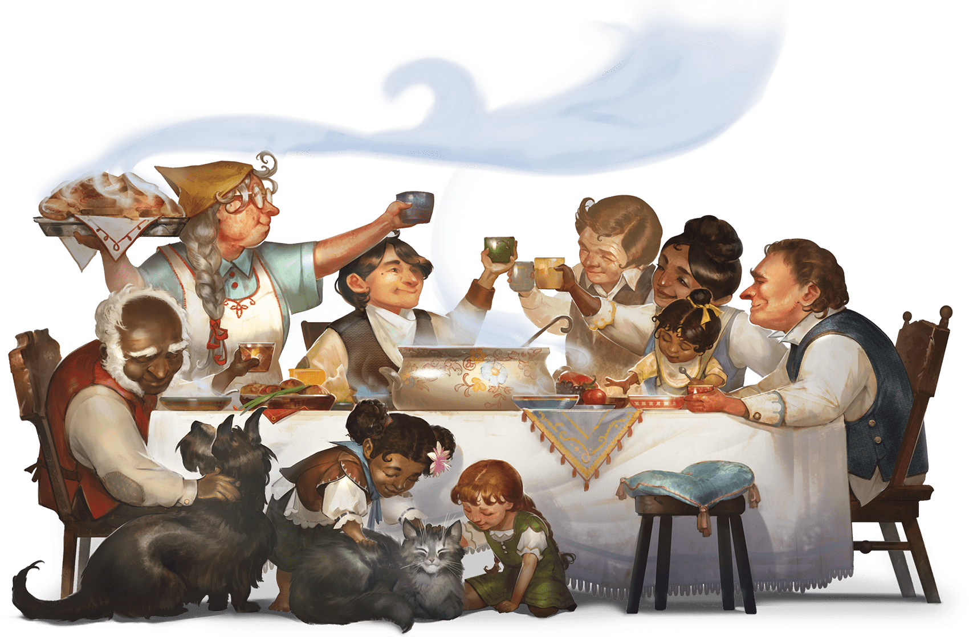](https://media.dndbeyond.com/compendium-images/phb/MKDHZ1nxSXDDLOw2/05-025.halfling.png)

Cherished and guided by gods who value life, home, and hearth, halflings gravitate toward bucolic havens where family and community help shape their lives. That said, many halflings possess a brave and adventurous spirit that leads them on journeys of discovery, affording them the chance to explore a bigger world and make new friends along the way. Their size—similar to that of a human child—helps them pass through crowds unnoticed and slip through tight spaces.

Anyone who has spent time around halflings, particularly halfling adventurers, has likely witnessed the storied “luck of the halflings” in action. When a halfling is in mortal danger, an unseen force seems to intervene on the halfling’s behalf. Many halflings believe in the power of luck, and they attribute their unusual gift to one or more of their benevolent gods, including Yondalla, Brandobaris, and Charmalaine. The same gift might contribute to their robust life spans (about 150 years).

Halfling communities come in all varieties. For every sequestered shire tucked away in an unspoiled part of the world, there’s a crime syndicate like the Boromar Clan in the Eberron setting or a territorial mob of halflings like those in the Dark Sun setting.

Halflings who prefer to live underground are sometimes called strongheart halflings or stouts. Nomadic halflings, as well as those who live among humans and other tall folk, are sometimes called lightfoot halflings or tallfellows.

**Halfling Traits**

**Creature Type:** Humanoid

**Size:** Small (about 2–3 feet tall)

**Speed:** 30 feet

As a Halfling, you have these special traits.

***Brave.*** You have **[Advantage](https://www.dndbeyond.com/sources/dnd/free-rules/rules-glossary" \l "Advantage)** on saving throws you make to avoid or end the [**Frightened**](https://www.dndbeyond.com/sources/dnd/free-rules/rules-glossary#FrightenedCondition) condition.

***Halfling Nimbleness.*** You can move through the space of any creature that is a size larger than you, but you can’t stop in the same space.

***Luck.*** When you roll a 1 on the d20 of a [**D20 Test**](https://www.dndbeyond.com/sources/dnd/free-rules/rules-glossary#D20Test), you can reroll the die, and you must use the new roll.

***Naturally Stealthy.*** You can take the [**Hide**](https://www.dndbeyond.com/sources/dnd/free-rules/rules-glossary#HideAction) action even when you are obscured only by a creature that is at least one size larger than you.

Human

**ZUZANNA WUZYK**[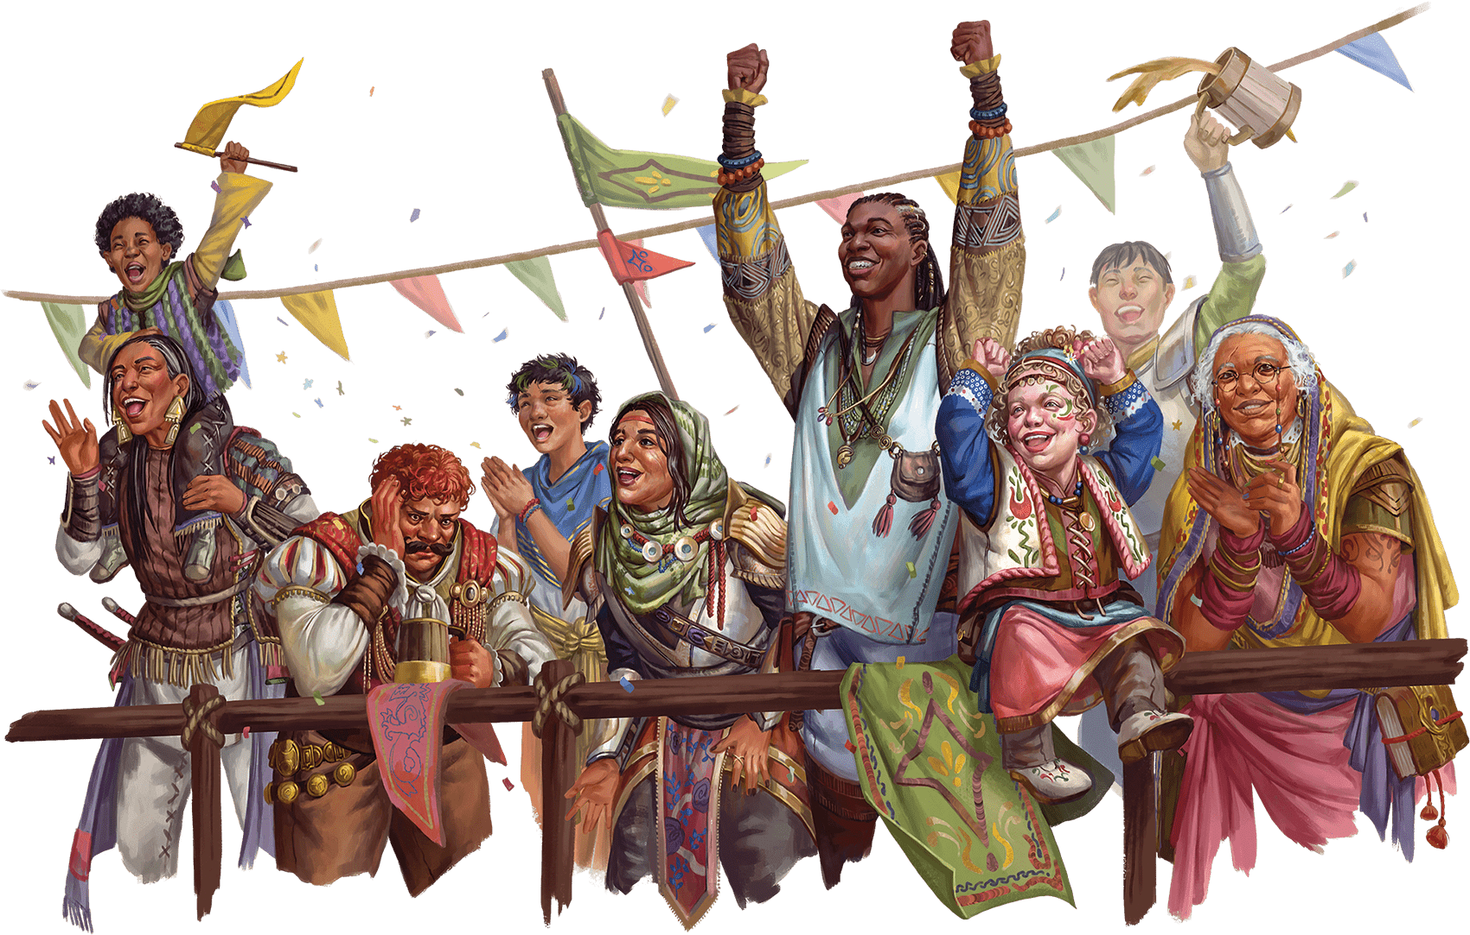](https://media.dndbeyond.com/compendium-images/phb/MKDHZ1nxSXDDLOw2/05-026.human.png)

Found throughout the multiverse, humans are as varied as they are numerous, and they endeavor to achieve as much as they can in the years they are given. Their ambition and resourcefulness are commended, respected, and feared on many worlds.

Humans are as diverse in appearance as the people of Earth, and they have many gods. Scholars dispute the origin of humanity, but one of the earliest known human gatherings is said to have occurred in Sigil, the torus-shaped city at the center of the multiverse and the place where the Common language was born. From there, humans could have spread to every part of the multiverse, bringing the City of Doors’ cosmopolitanism with them.

**WAYNE ENGLAND**[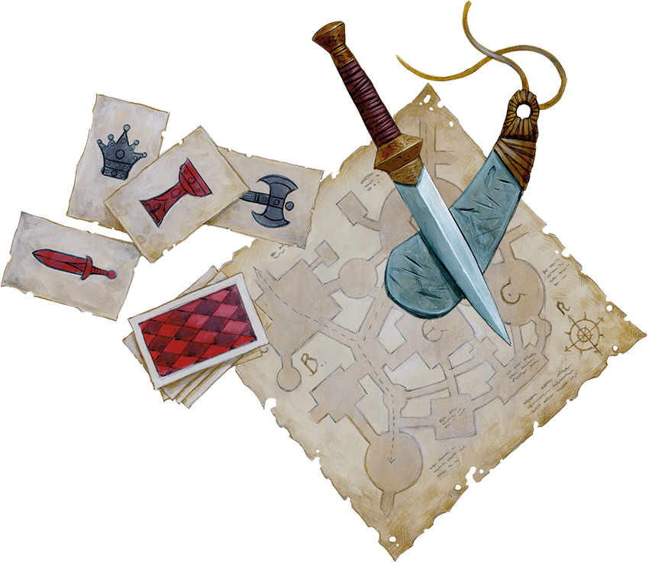](https://media.dndbeyond.com/compendium-images/phb/MKDHZ1nxSXDDLOw2/05-027.map-decoration.png)

**Human Traits**

**Creature Type:** Humanoid

**Size:** Medium (about 4–7 feet tall) or Small (about 2–4 feet tall), chosen when you select this species

**Speed:** 30 feet

As a Human, you have these special traits.

***Resourceful.*** You gain [**Heroic Inspiration**](https://www.dndbeyond.com/sources/dnd/free-rules/rules-glossary#HeroicInspiration) whenever you finish a [**Long Rest**](https://www.dndbeyond.com/sources/dnd/free-rules/rules-glossary#LongRest).

***Skillful.*** You gain proficiency in one skill of your choice.

***Versatile.*** You gain an Origin feat of your choice (see [chapter 5](https://www.dndbeyond.com/sources/dnd/phb-2024/feats#OriginFeats)). [Skilled](https://www.dndbeyond.com/sources/dnd/phb-2024/feats#Skilled) is recommended.

Orc

**MIKE PAPE**[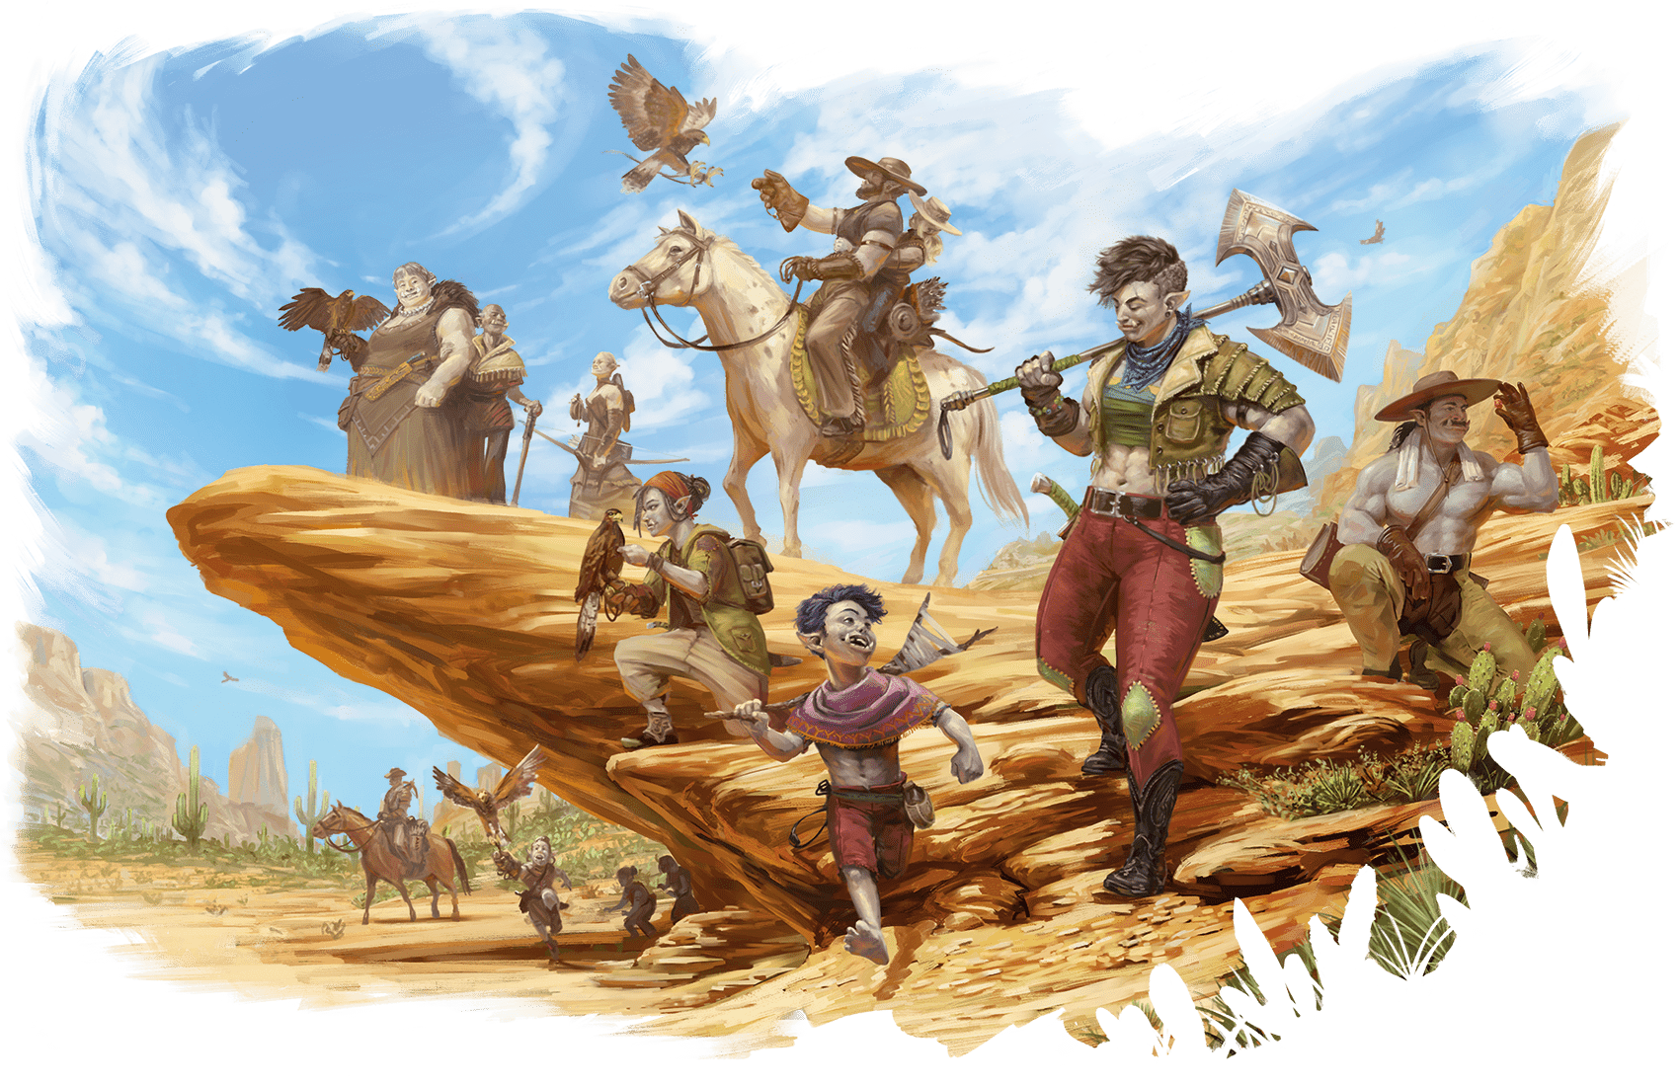](https://media.dndbeyond.com/compendium-images/phb/MKDHZ1nxSXDDLOw2/05-027.orc.png)

Orcs trace their creation to Gruumsh, a powerful god who roamed the wide open spaces of the Material Plane. Gruumsh equipped his children with gifts to help them wander great plains, vast caverns, and churning seas and to face the monsters that lurk there. Even when they turn their devotion to other gods, orcs retain Gruumsh’s gifts: endurance, determination, and the ability to see in darkness.

Orcs are, on average, tall and broad. They have gray skin, ears that are sharply pointed, and prominent lower canines that resemble small tusks. Orc youths on some worlds are told about their ancestors’ great travels and travails. Inspired by those tales, many of those orcs wonder when Gruumsh will call on them to match the heroic deeds of old and if they will prove worthy of his favor. Other orcs are happy to leave old tales in the past and find their own way.

**Orc Traits**

**Creature Type:** Humanoid

**Size:** Medium (about 6–7 feet tall)

**Speed:** 30 feet

As an Orc, you have these special traits.

***Adrenaline Rush.*** You can take the [**Dash**](https://www.dndbeyond.com/sources/dnd/free-rules/rules-glossary#DashAction) action as a Bonus Action. When you do so, you gain a number of [**Temporary Hit Points**](https://www.dndbeyond.com/sources/dnd/free-rules/rules-glossary#TemporaryHitPoints) equal to your Proficiency Bonus. You can use this trait a number of times equal to your Proficiency Bonus, and you regain all expended uses when you finish a [**Short**](https://www.dndbeyond.com/sources/dnd/free-rules/rules-glossary#ShortRest) or [**Long Rest**](https://www.dndbeyond.com/sources/dnd/free-rules/rules-glossary#LongRest).

***Darkvision.*** You have [**Darkvision**](https://www.dndbeyond.com/sources/dnd/free-rules/rules-glossary#Darkvision) with a range of 120 feet.

***Relentless Endurance.*** When you are reduced to 0 Hit Points but not killed outright, you can drop to 1 Hit Point instead. Once you use this trait, you can’t do so again until you finish a [**Long Rest**](https://www.dndbeyond.com/sources/dnd/free-rules/rules-glossary#LongRest).

Tiefling

**CLINT CEARLEY**[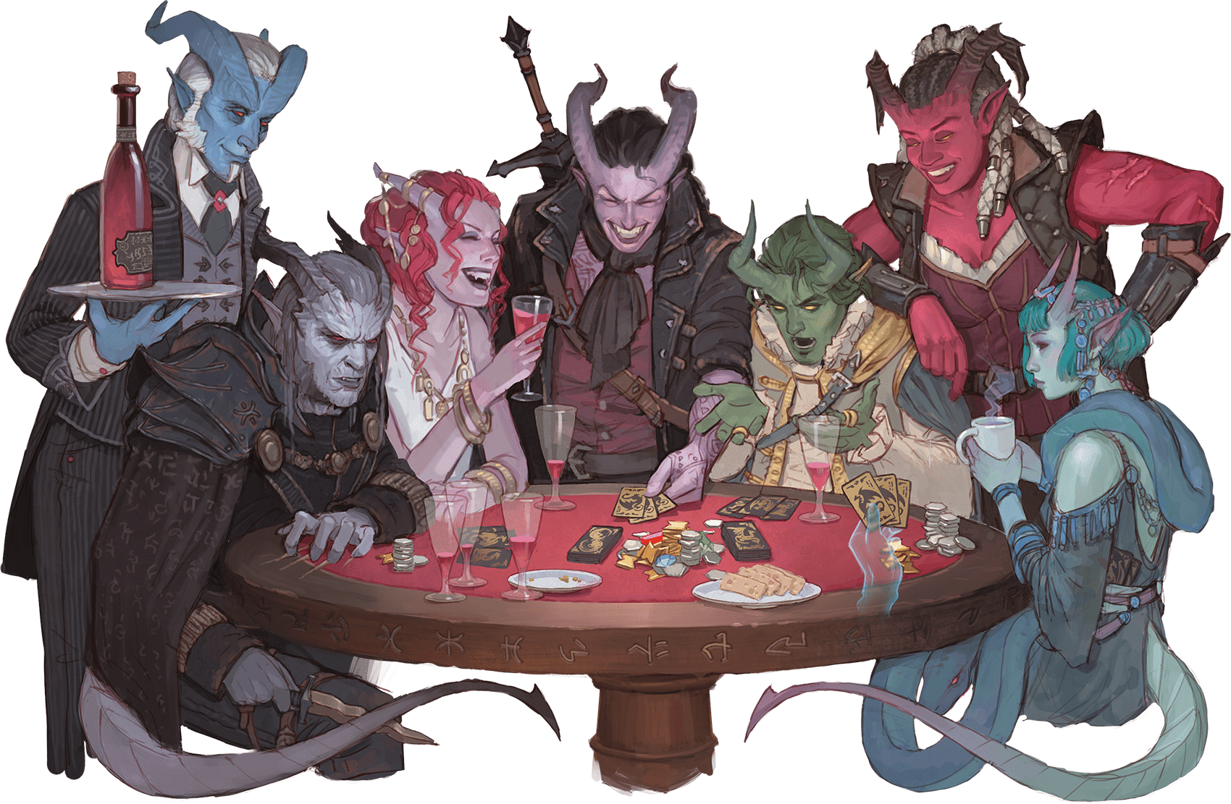](https://media.dndbeyond.com/compendium-images/phb/MKDHZ1nxSXDDLOw2/05-030.tiefling.png)

Tieflings are either born in the Lower Planes or have fiendish ancestors who originated there. A tiefling (pronounced TEE-fling) is linked by blood to a devil, a demon, or some other Fiend. This connection to the Lower Planes is the tiefling’s fiendish legacy, which comes with the promise of power yet has no effect on the tiefling’s moral outlook.

A tiefling chooses whether to embrace or lament their fiendish legacy. The three legacies are described below.

**Abyssal**

The entropy of the Abyss, the chaos of Pandemonium, and the despair of Carceri call to tieflings who have the abyssal legacy. Horns, fur, tusks, and peculiar scents are common physical features of such tieflings, most of whom have the blood of demons coursing through their veins.

**Chthonic**

Tieflings who have the chthonic legacy feel not only the tug of Carceri but also the greed of Gehenna and the gloom of Hades. Some of these tieflings look cadaverous. Others possess the unearthly beauty of a succubus, or they have physical features in common with a night hag, a yugoloth, or some other Neutral Evil fiendish ancestor.

**Infernal**

The infernal legacy connects tieflings not only to Gehenna but also the Nine Hells and the raging battlefields of Acheron. Horns, spines, tails, golden eyes, and a faint odor of sulfur or smoke are common physical features of such tieflings, most of whom trace their ancestry to devils.

**JOHN GRELLO**[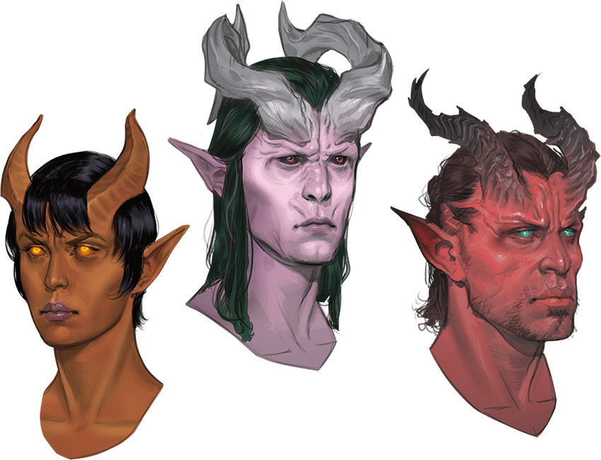](https://media.dndbeyond.com/compendium-images/phb/MKDHZ1nxSXDDLOw2/05-029.infernal-chthonic-abyssal.png)Infernal Tiefling, Chthonic Tiefling, Abyssal Tiefling

**Tiefling Traits**

**Creature Type:** Humanoid

**Size:** Medium (about 4–7 feet tall) or Small (about 3–4 feet tall), chosen when you select this species

**Speed:** 30 feet

As a Tiefling, you have the following special traits.

***Darkvision.*** You have [**Darkvision**](https://www.dndbeyond.com/sources/dnd/free-rules/rules-glossary#Darkvision) with a range of 60 feet.

***Fiendish Legacy.*** You are the recipient of a legacy that grants you supernatural abilities. Choose a legacy from the Fiendish Legacies table. You gain the level 1 benefit of the chosen legacy.

**JODIE MUIR**[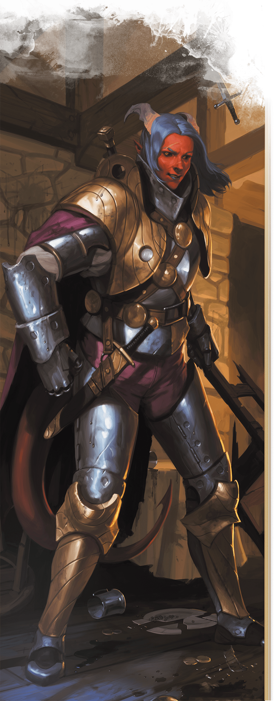](https://media.dndbeyond.com/compendium-images/phb/MKDHZ1nxSXDDLOw2/05-028.armored-tiefling.png)

When you reach character levels 3 and 5, you learn a higher-level spell, as shown on the table. You always have that spell prepared. You can cast it once without a spell slot, and you regain the ability to cast it in that way when you finish a [**Long Rest**](https://www.dndbeyond.com/sources/dnd/free-rules/rules-glossary#LongRest). You can also cast the spell using any spell slots you have of the appropriate level. Intelligence, Wisdom, or Charisma is your spellcasting ability for the spells you cast with this trait (choose the ability when you select the legacy).

***Otherworldly Presence.*** You know the [***Thaumaturgy***](https://www.dndbeyond.com/spells/2619174-thaumaturgy) cantrip. When you cast it with this trait, the spell uses the same spellcasting ability you use for your Fiendish Legacy trait.

| **Fiendish Legacies** | | | |
| --- | --- | --- | --- |
| **Legacy** | **Level 1** | **Level 3** | **Level 5** |
| Abyssal | You have Resistance to Poison damage. You also know the ***[Poison Spray](https://www.dndbeyond.com/spells/2618875-poison-spray)*** cantrip. | [***Ray of Sickness***](https://www.dndbeyond.com/spells/2618935-ray-of-sickness) | [***Hold Person***](https://www.dndbeyond.com/spells/2619153-hold-person) |
| Chthonic | You have Resistance to Necrotic damage. You also know the [***Chill Touch***](https://www.dndbeyond.com/spells/2618965-chill-touch) cantrip. | [***False Life***](https://www.dndbeyond.com/spells/2618866-false-life) | [***Ray of Enfeeblement***](https://www.dndbeyond.com/spells/2618926-ray-of-enfeeblement) |
| Infernal | You have Resistance to Fire damage. You also know the [***Fire Bolt***](https://www.dndbeyond.com/spells/2618890-fire-bolt) cantrip. | [***Hellish Rebuke***](https://www.dndbeyond.com/spells/2619149-hellish-rebuke) | [***Darkness***](https://www.dndbeyond.com/spells/2619080-darkness) |